**Twitter Sentiment Streaming Analysis**

**Website Link (Need Link)**

**Team 12:**

**Priti**

**Yalin**

**Zhi**

**Final Project: Twitter Sentiment Streaming Analysis**

Contents

About Dataset: 2

Problem Statement 2

Data Preparation & Cleansing 3

Data Visualization 6

Data Modelling 16

Deploying the Web Service 19

Integration of Front end and REST API 21

# About Dataset:

The dataset contains static and dynamic tweets, which was collected by using the Twitter Search API and keywords search.

Static Data: Twitter tweets were collected for keywords “iphone” and “ipad”

Live Data: Twitter tweets were continuously collected for dynamic keywords inputted bt user using streaming API

**Basic Deployment Pipeline**: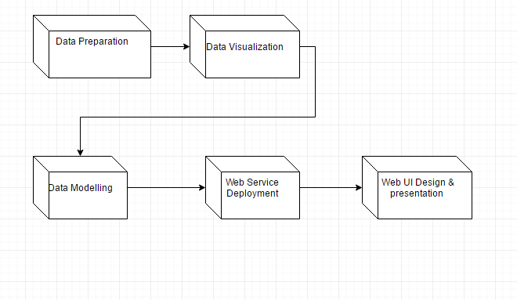

# Data Preparation & Cleansing

Tools Used: R script was used for preprocessing and cleaning the data.

Steps:

1. Find most popular Key words, and get the static data for training model.
2. Register a Twitter Account at <http://twitter.com>.
3. Create a Twitter Application at <http://apps.twitter.com>. 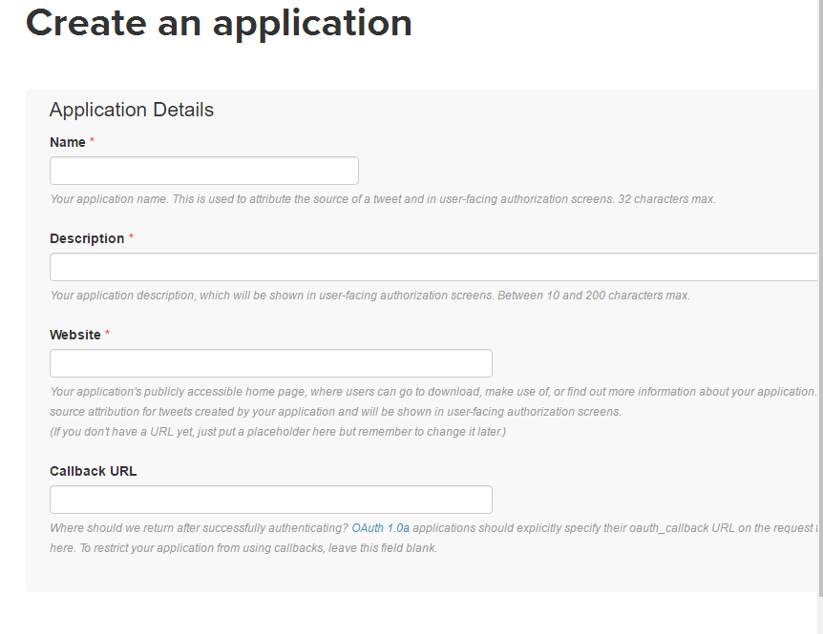
4. Twitter’s Streaming API OAuth credentials

* One the Twitter application page, click one the Kets and Access Tokens tab.
* Consumer Key(API Key) and Consumer Secret(API Secret) can be found under Application Settings.
* Under Your Access Token section, click on Create my access token to obtain both Access Token and Access Token Secret. 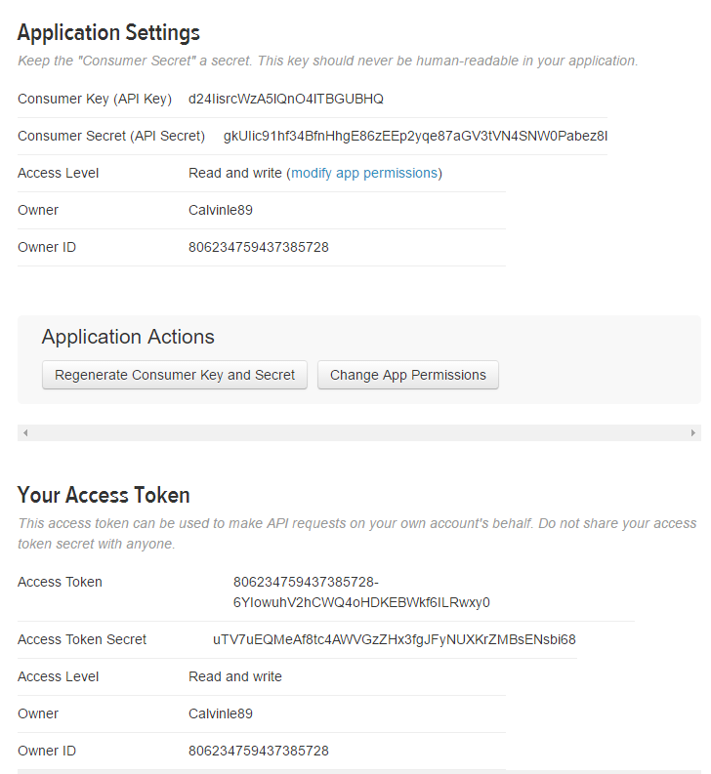

**Building Static data:**

1. Using R script to get static data to build model by Key words. 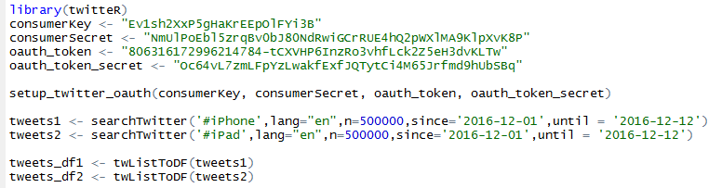
2. Clean the data by using R script to normalize the original data.
   1. Delete needless symbols of “Text” (tweets).
   2. Calculate sentiments by using functions.
   3. Count all mapped positive and negative words and subtract the latter from the former

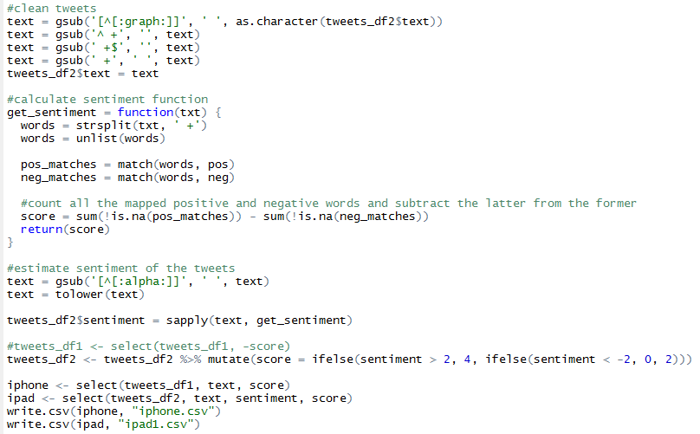

**Building Live data:**

1. Live data is collected using filterStream giving a timeout = 10sec

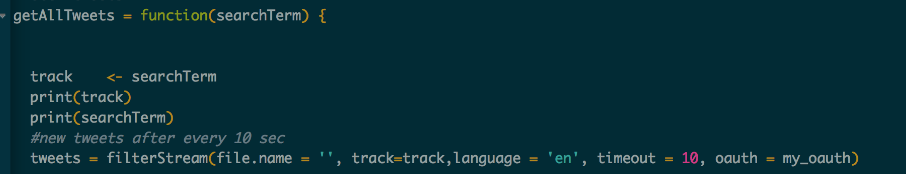

Dashboard 1:

**Purpose: Perform LIVE sentiment analysis on two different keywords and perform LIVE visualizations in order to determine negative and positive sentiments across various areas**

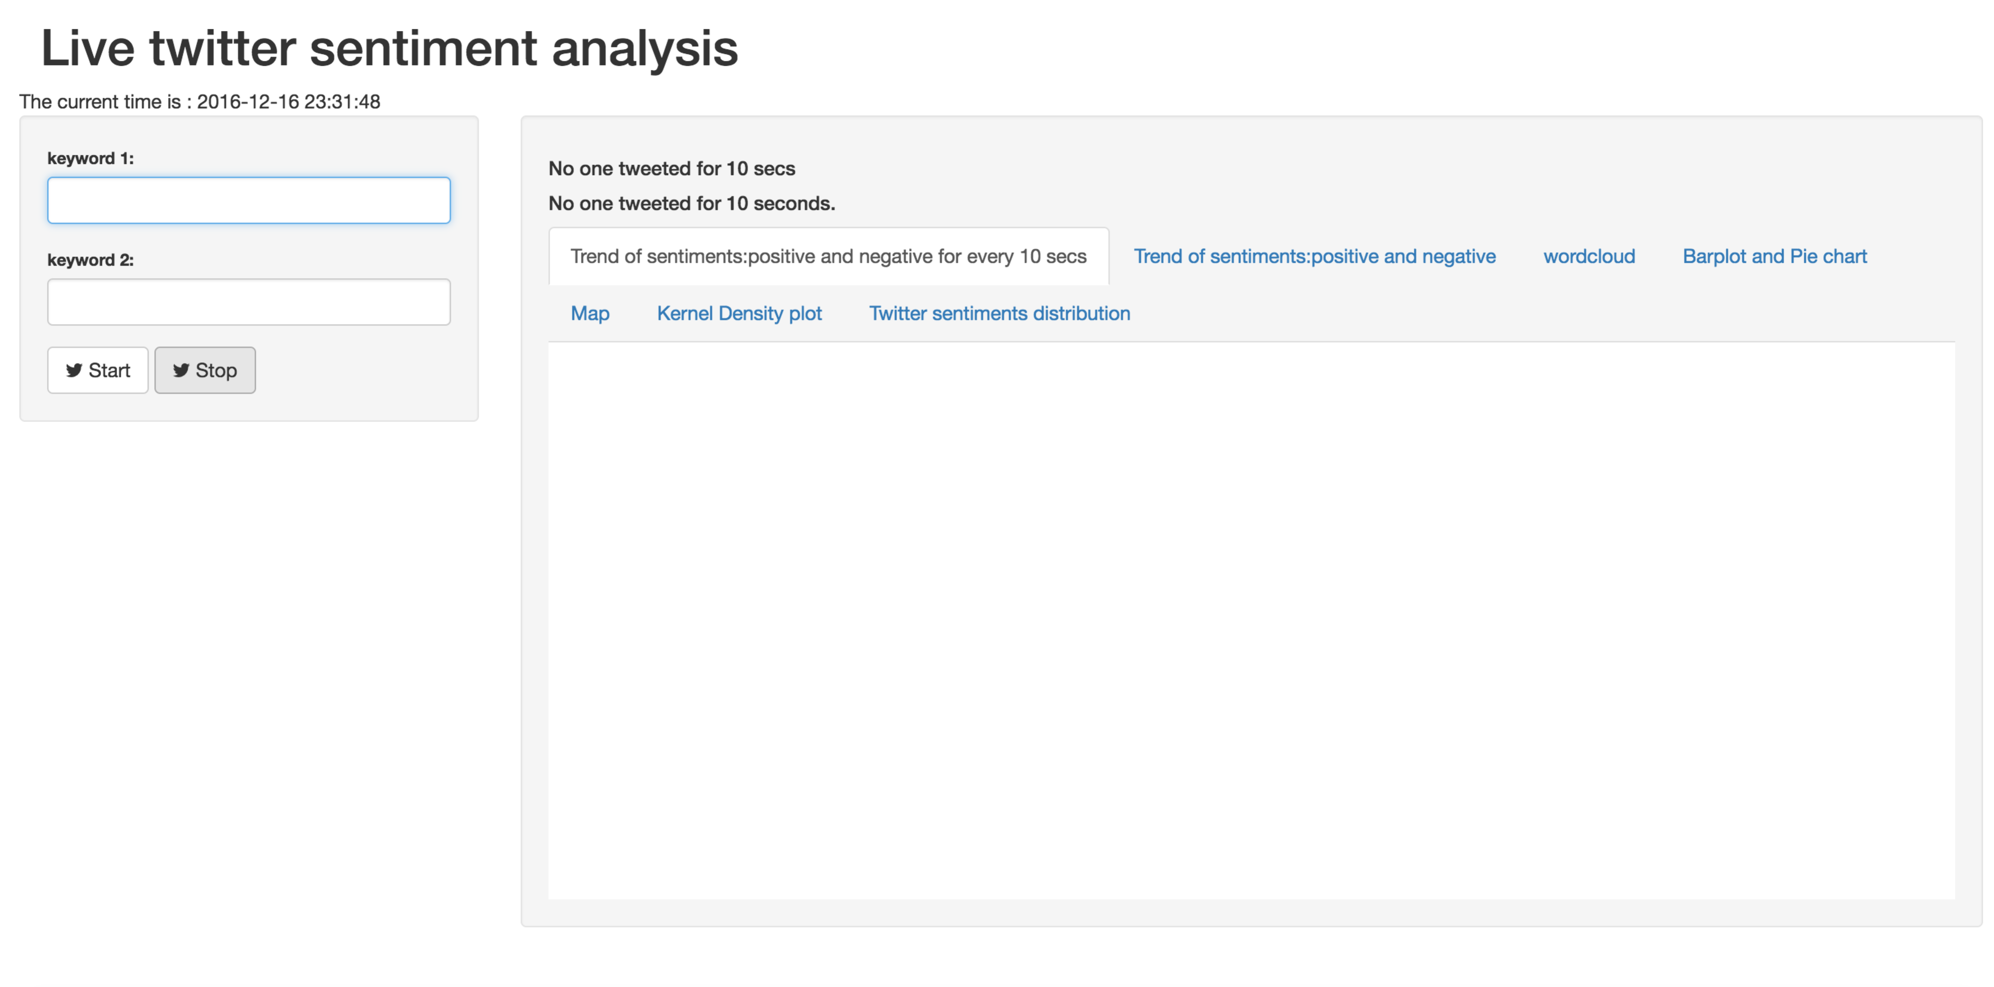

**Description:** This can be rather called a product as it accepts two dynamic keywords. Eg: Trump and Hillary. It basically retrieves live tweets and one can determine sentiments and emotions of people regarding the two politicians. Tweet feeds are refreshed every 10 secs and the visualizations are also refreshed every 10 secs.

**Enter keywords here**: As soon as start button is pressed, live tweets are collected until 10 secs and visualizations are plotted.

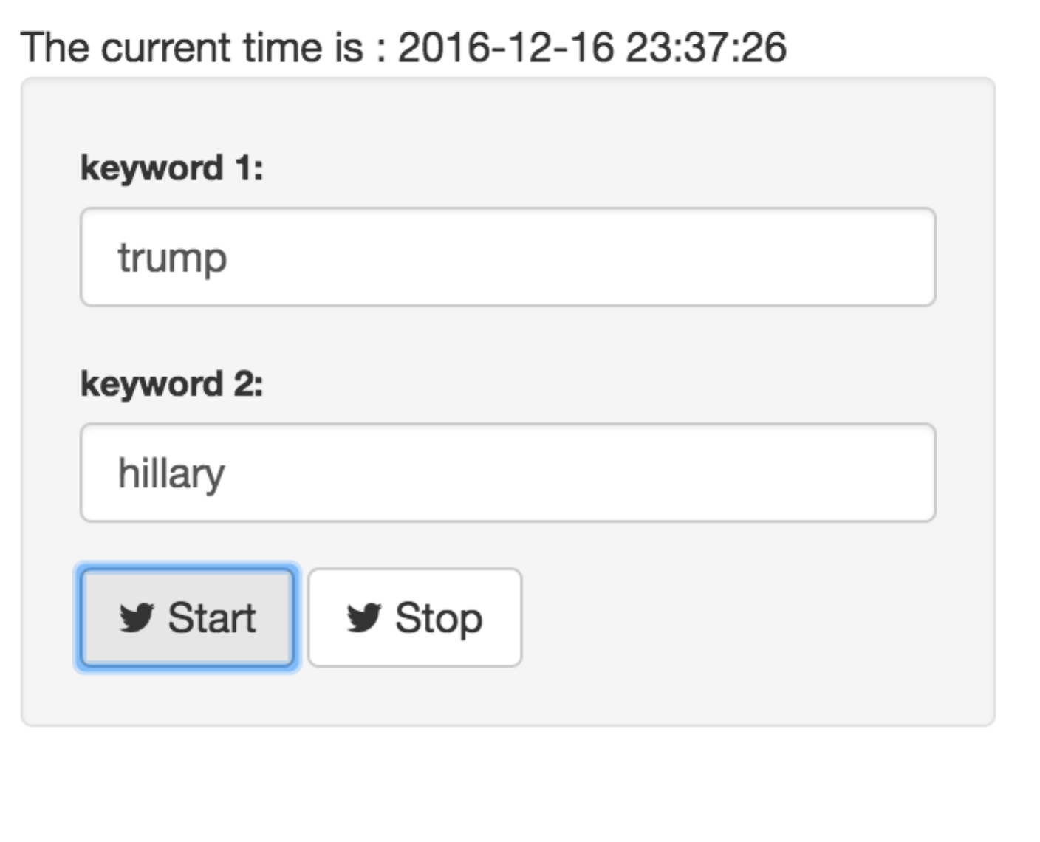

Sample positive and negative tweets: Live sample of tweets are displayed. Huge tweets data are analyzed and cleaned. Once cleaning is done, sentiment score is calculated and recognized into: “Positive”, “negative”, “neutral”

From a list of positive and negative tweets, one tweet is chosen at random and displayed on dashboard

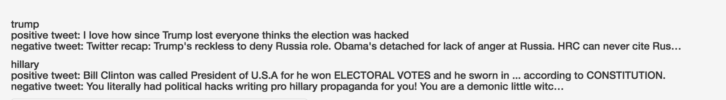

clean tweets:

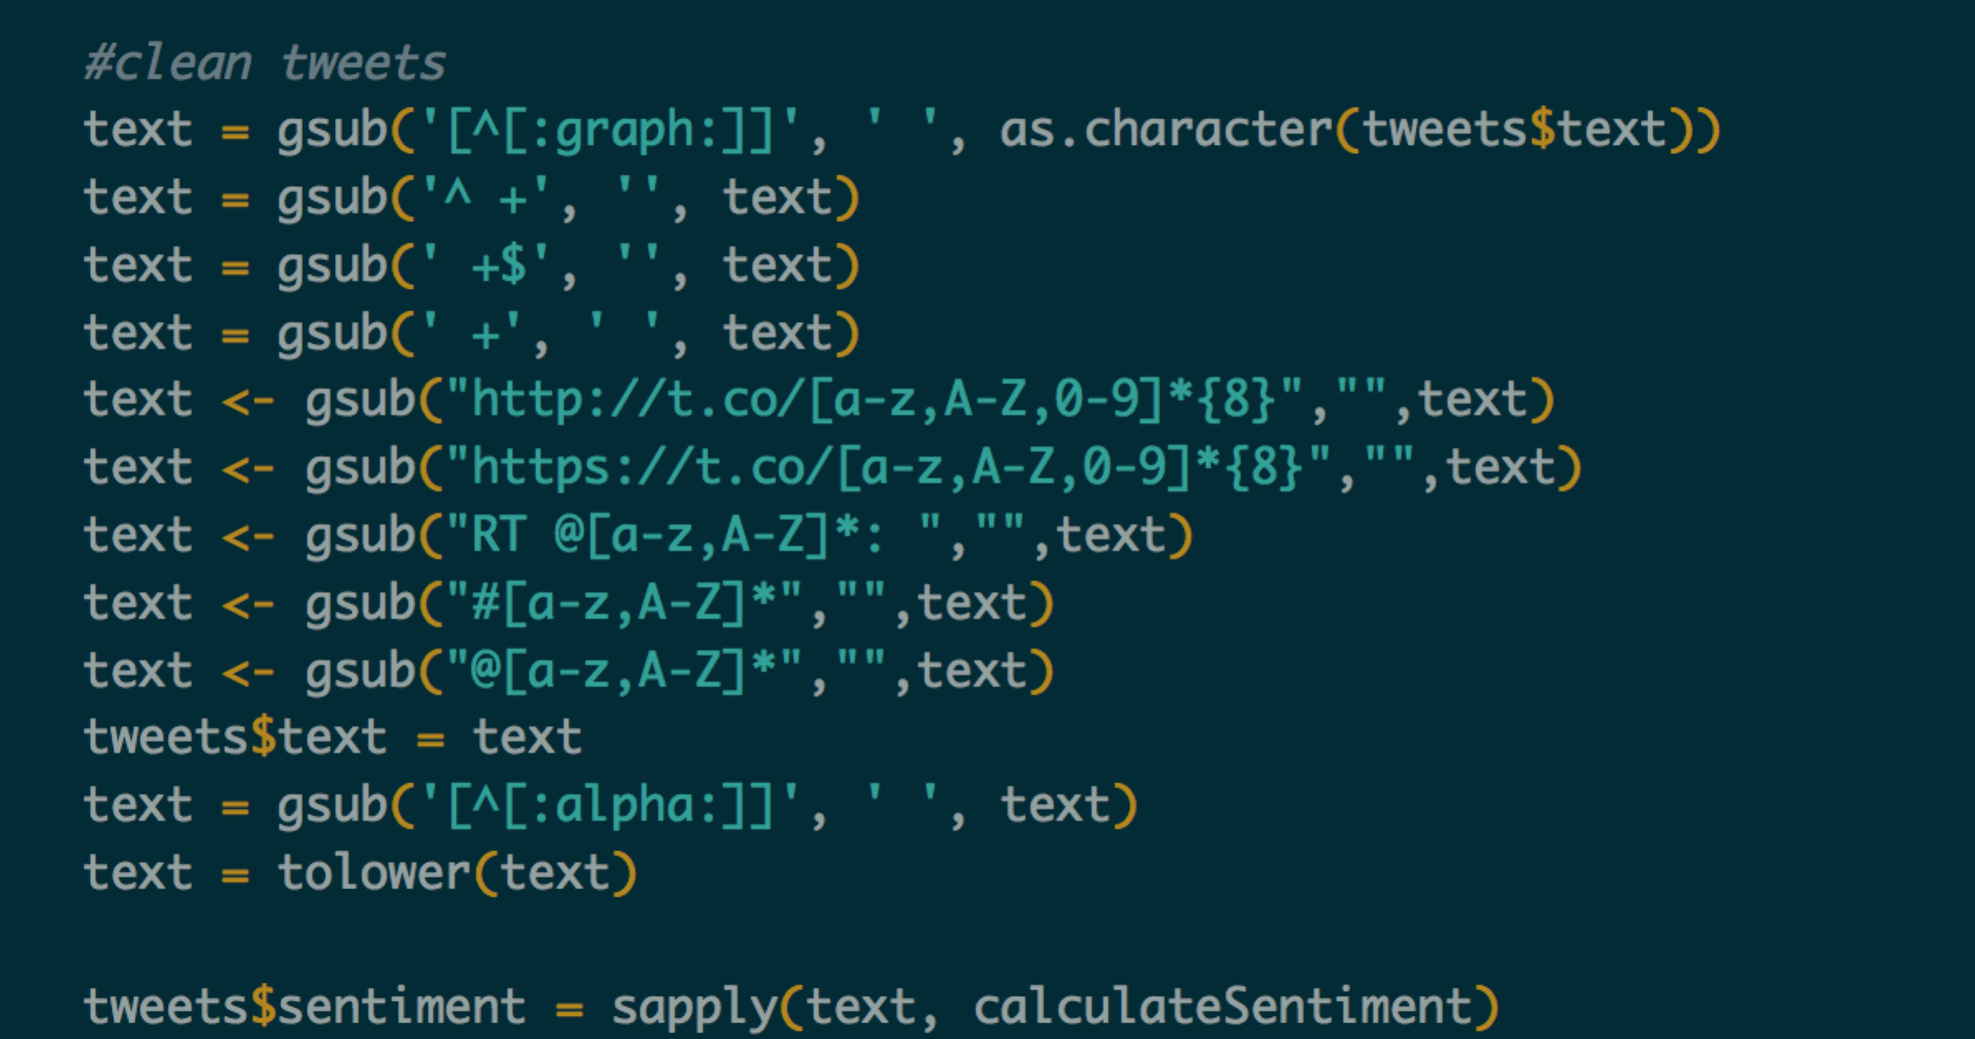

Calculate sentiment score:

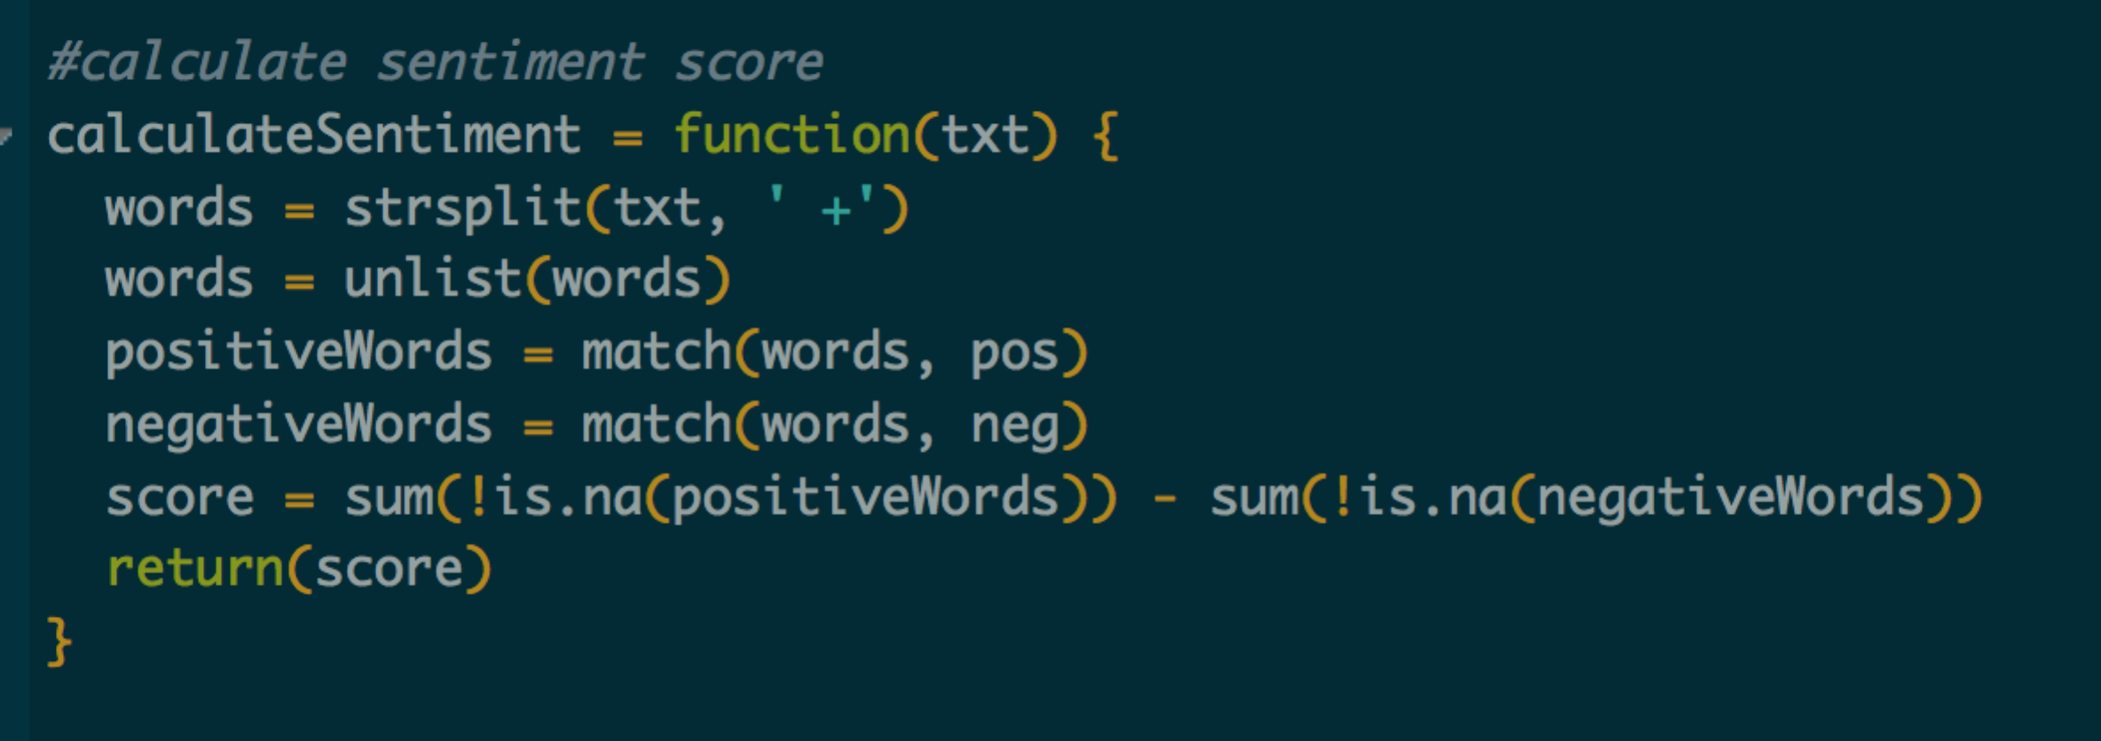

Trend of sentiments - positive and negative for every 10 secs: Every 10 secs, sentiment score for tweets is calculated and displayed as below:

**Observation**: There are more tweets for Trump as compared to Hillary. Also, Hillary has more tweets with negative sentiments. Trump has received more positive and more number of tweets. This shows that sentiments of people towards Trump is more positive than Hillary

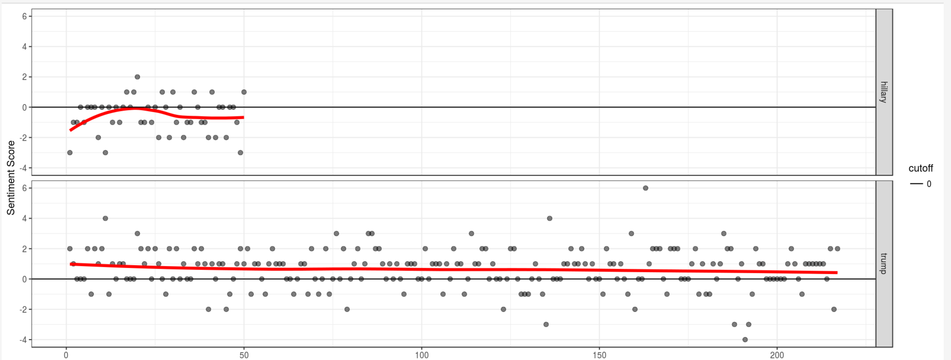

Plot: geom_smooth is used for ggplot. It is called as smoothed conditional means. It helps in viewing the patterns in the presence of overplotting.

Method:loess – local polynomial regression fitting.

It fits a polynomial surface determined by one or more numerical predictors, using local fitting.

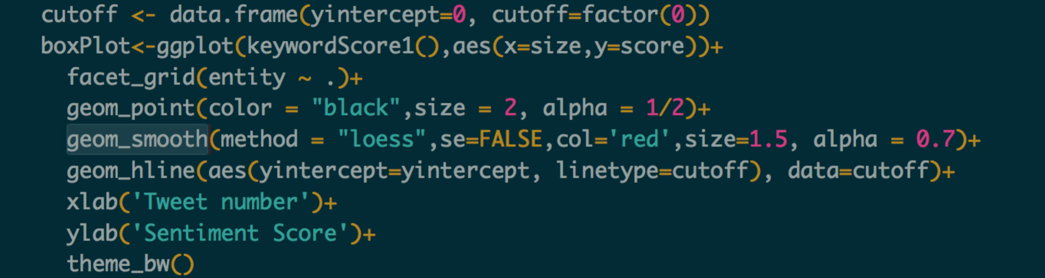

Trends of positive and negative sentiments - combined: Every 10 secs, sentiment score for tweets are calculated. The score is summed up for each 10 secs and plot is displayed from start time till present time. Each line represents the sentiments of people from each continent. Hence, one can understand emotions of people distributed among continents.

**Observation**: Sentiments of people for trump is more towards positive in each continent, while it keeps fluctuating in case of Asia and Oceania. Sentiments of people for Hillary are mostly negative, then neutral then positive in Europe while neutral in case of North America.

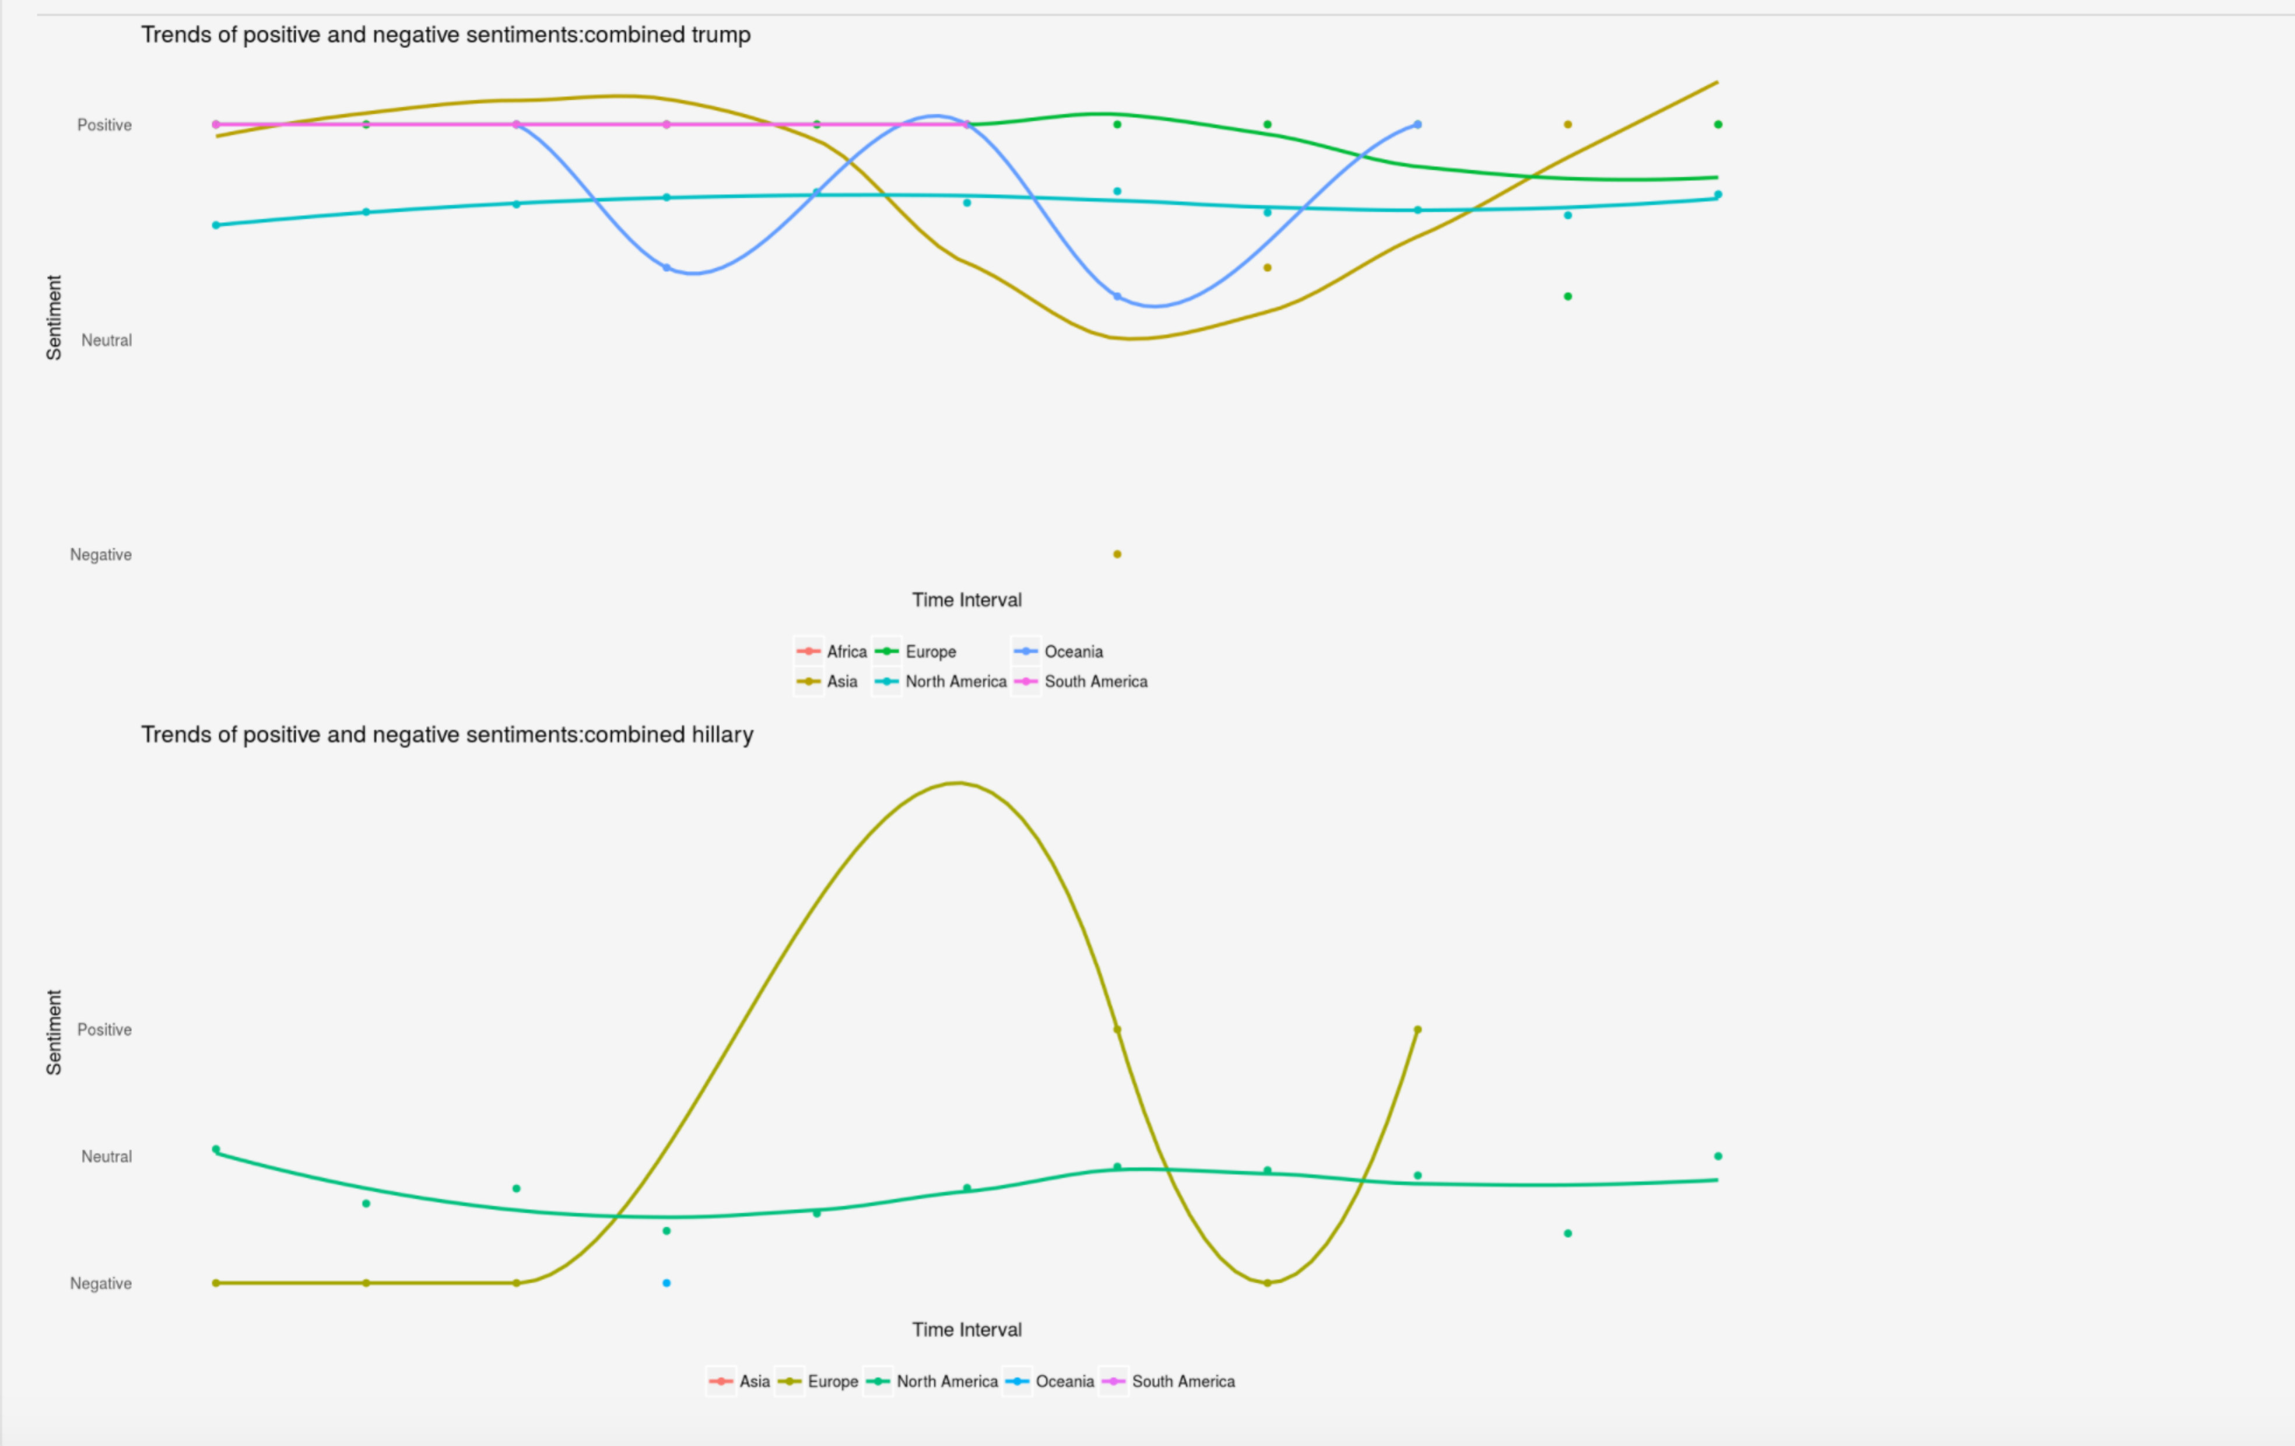

Plot: stat_smooth is used for ggplot. It is called as smoothed conditional means.

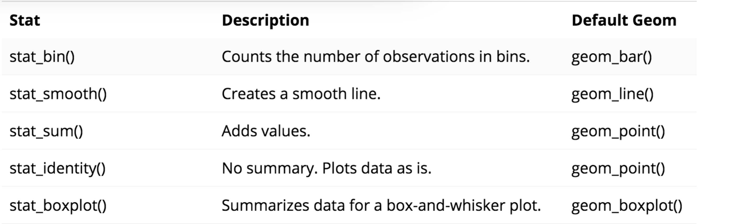

The interesting thing about stat_smooth() is that it makes use of local regression by default. R has several functions that can do this, but ggplot2 uses the loess() function for local regression. This means that if you want to create a linear regression model you have to tell stat_smooth() to use a different smoother function.

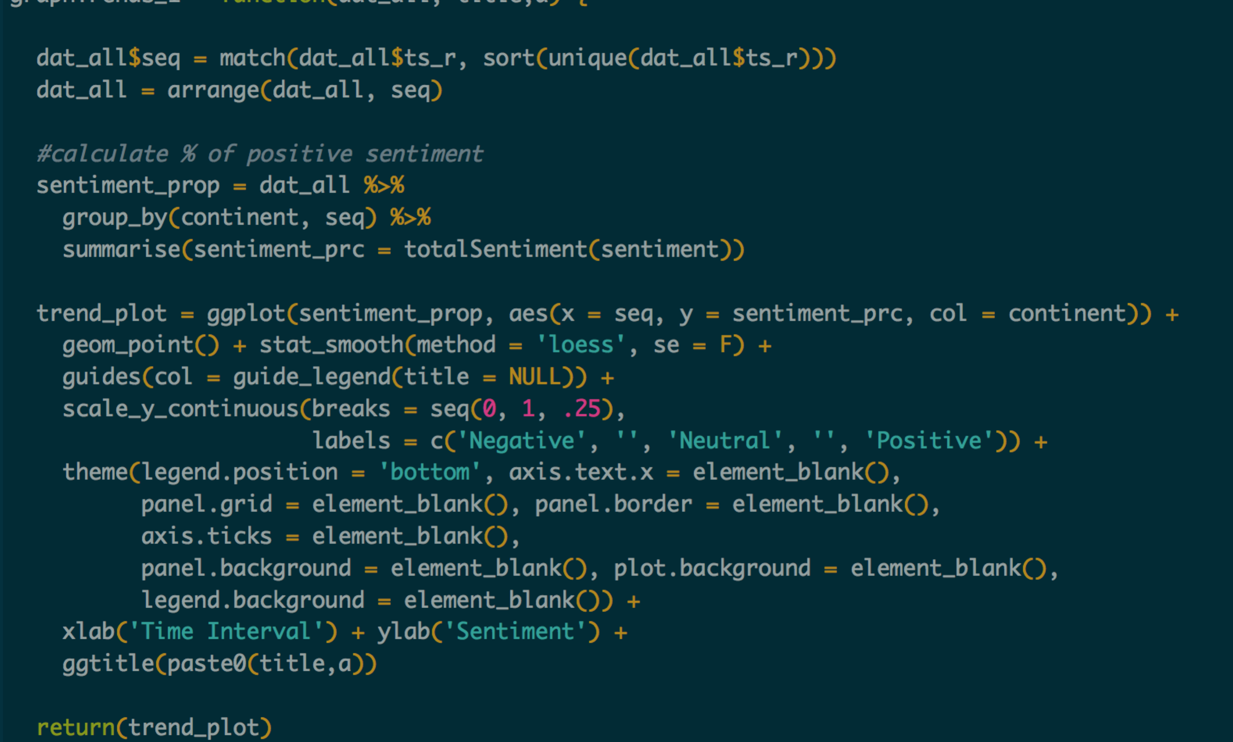

Wordcloud:  Word cloud is a text mining method that allows us to highlight the most frequently used keywords in a paragraph of texts. It is also referred to as a text cloud or tag cloud. Word clouds (also known as text clouds or tag clouds) work in a simple way: the more a specific word appears in a source of textual data (such as a speech, blog post, or database), the bigger and bolder it appears in the word cloud.

**Observation**: For trump, frequently used words are ‘Russia’ and ‘election’. Other words are surrounded around. For Hillary, ‘obama’ is most frequently used.

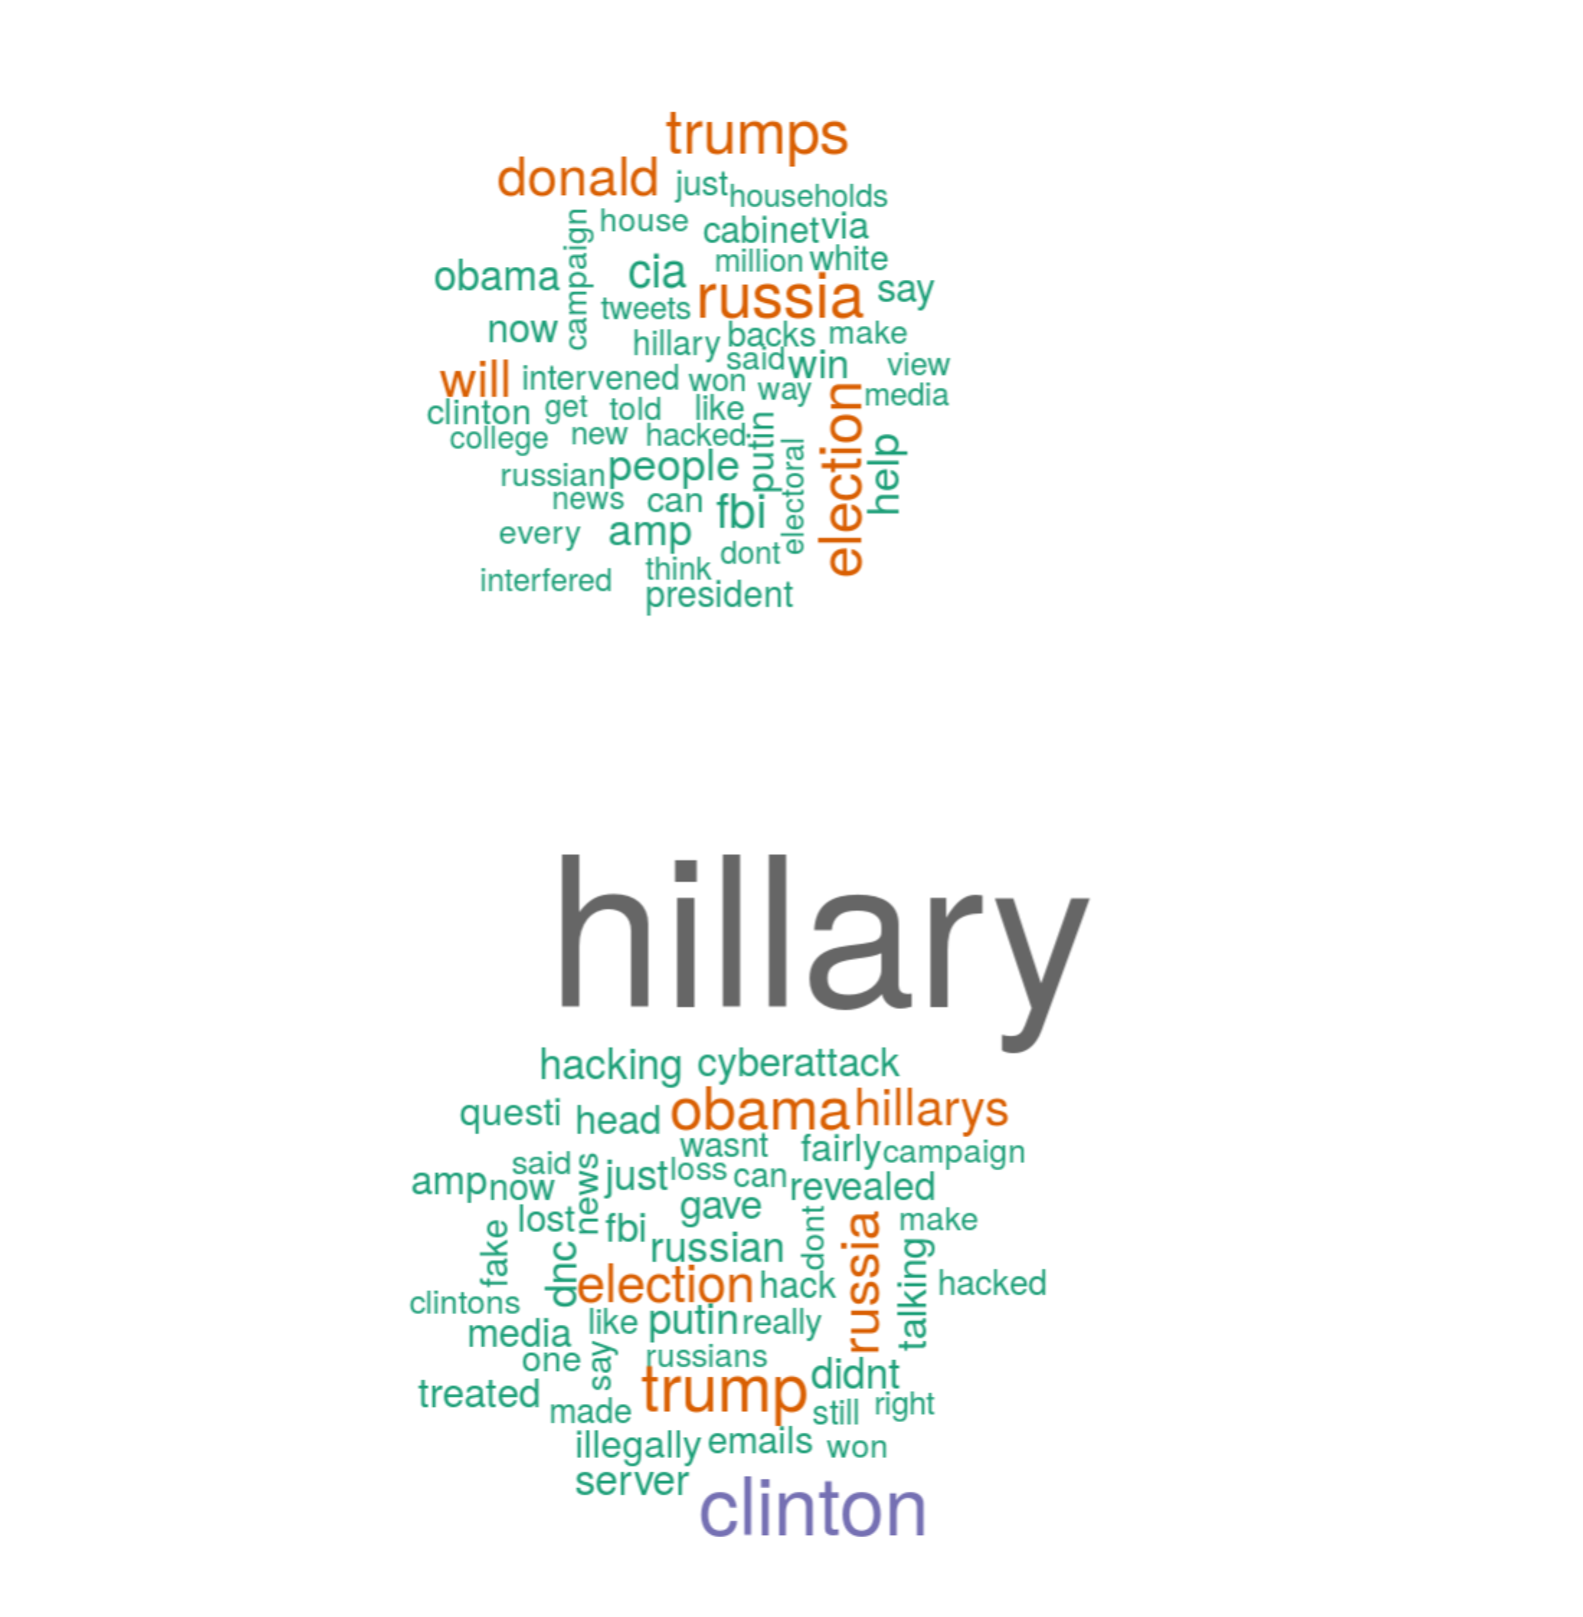

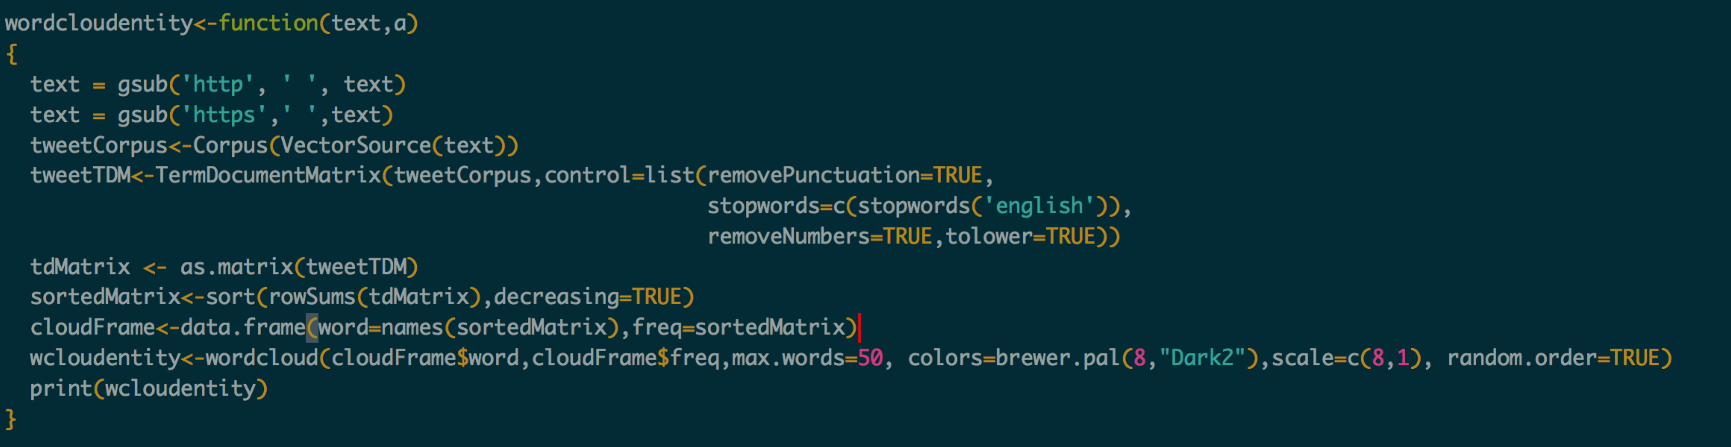

Bar Charts and Pie charts: A bar chart or bar graph is a chart or graph that presents [grouped data](https://en.wikipedia.org/wiki/Categorical_variable) with rectangular bars with [lengths](https://en.wikipedia.org/wiki/Length) proportional to the values that they represent. Pie chart is a type of graph in which a circle is divided into sectors that each represents a proportion of the whole

**Observation**: For trump, positive percentage of tweets is 58%, negative: 14%, neutral: 28%. For Hillary, positive: 26%, 43%, 31%. Bar graph visualizes the count of type of tweets

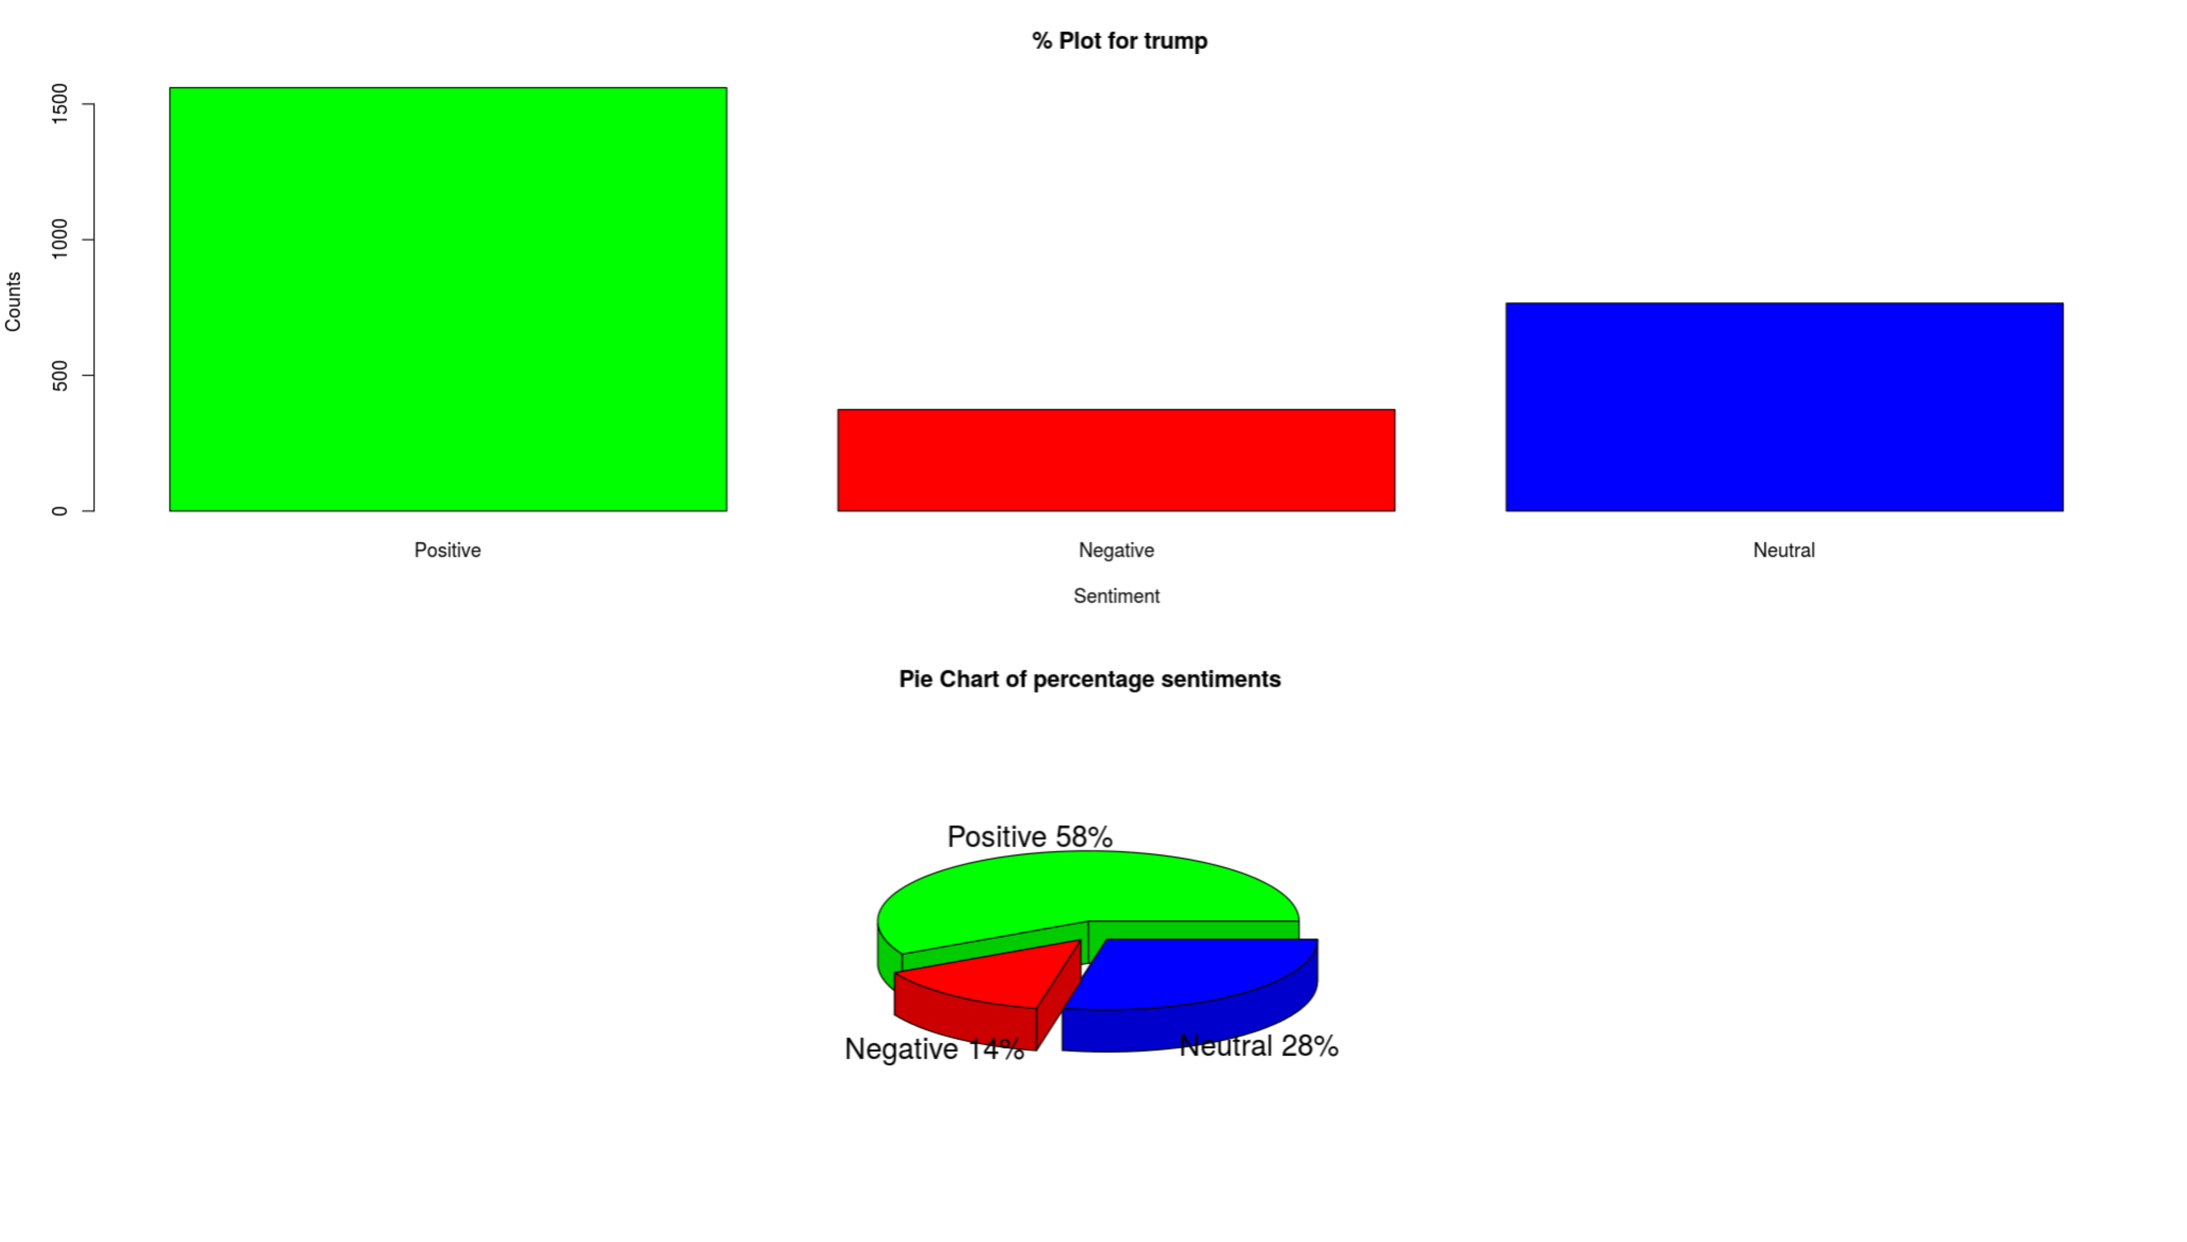

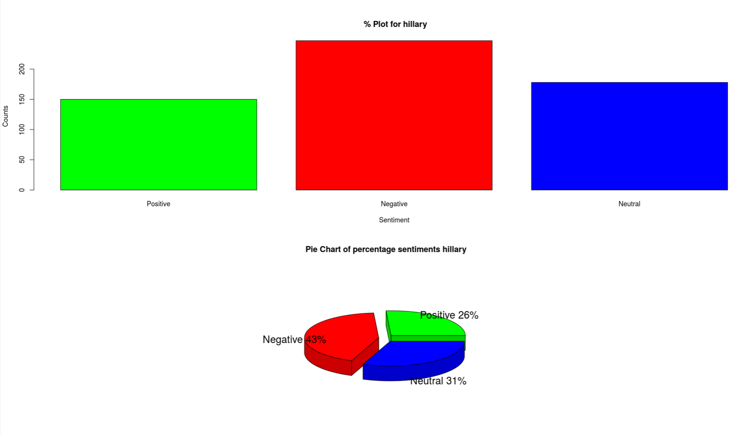

**Bar graph**:

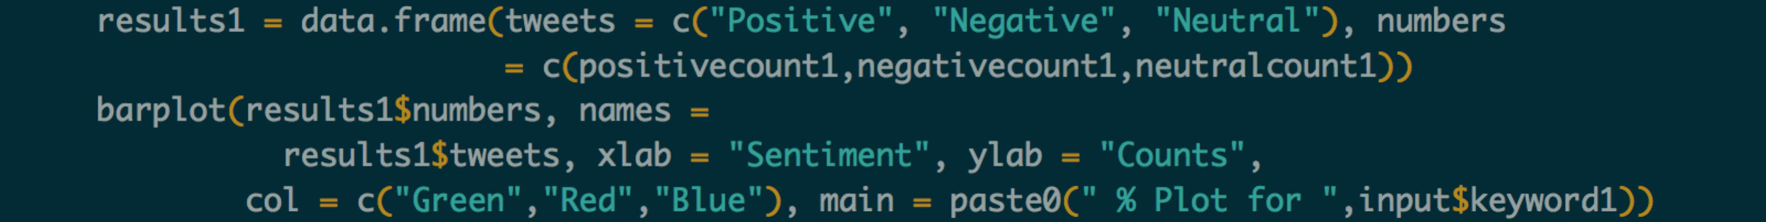

**Pie chart**:

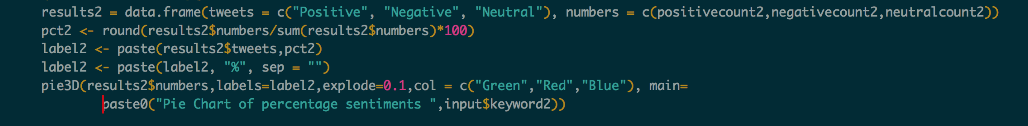

Map: Plots world map and views distribution of tweet sentiments in each continent.

**Observation**: For trump, there are more positive tweets in North America. For Hillary, there are more negative tweets in North America

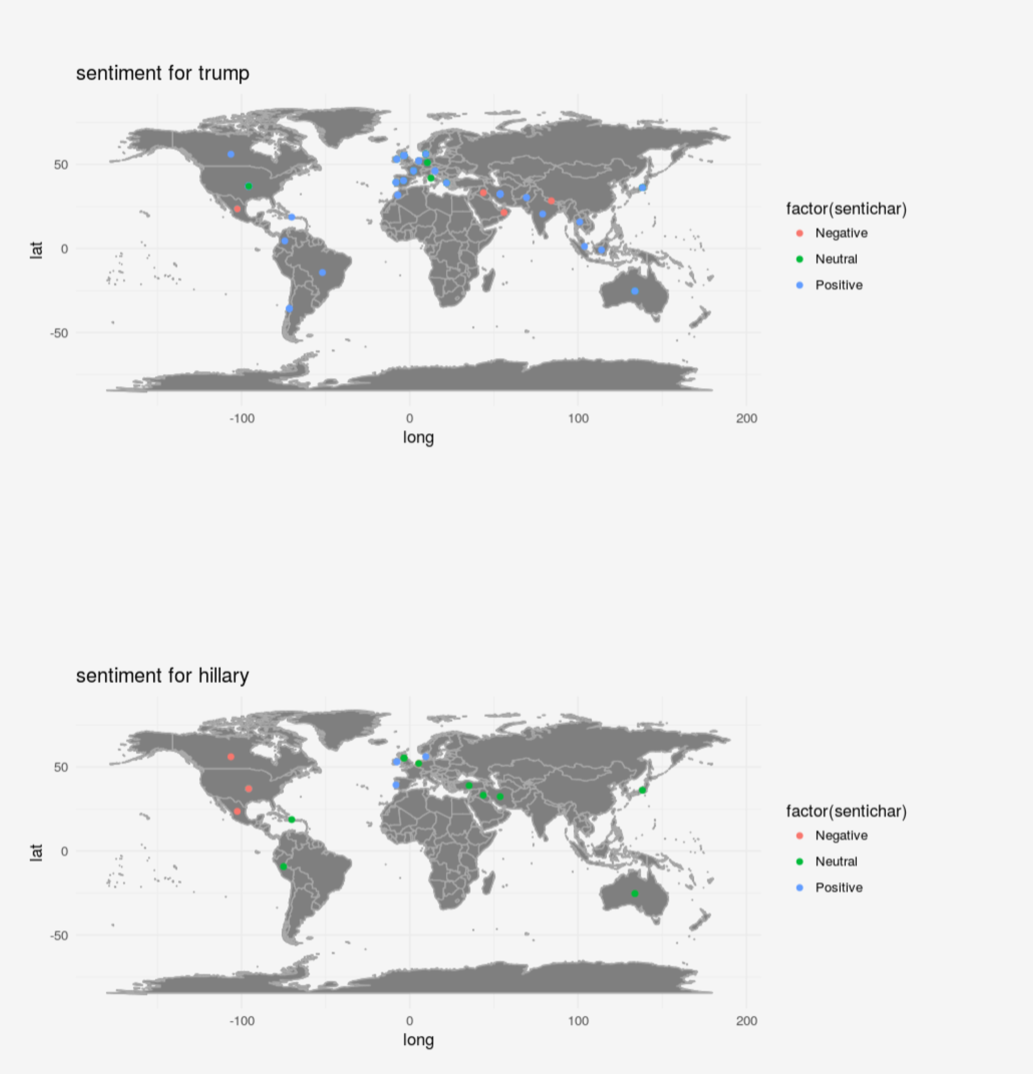

ggmap: A collection of functions to visualize spatial data and models on top of static maps from various online sources (e.g Google Maps and Stamen Maps). It includes tools common to those tasks, including functions for geolocation and routing

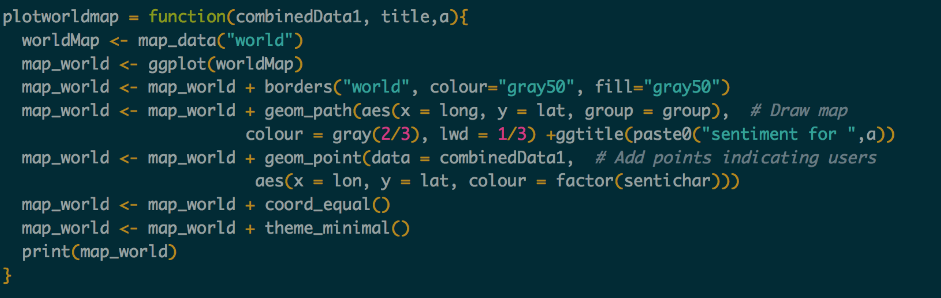

Kernel Density plot**:** Technique for visualizing the underlying distribution of a continuous variable. Kernel density plot is a non-parametric way to estimate the probability density function of a random variable. Kernel density estimation is a fundamental data-smoothing problem where inferences about the tweets are made, based on a finite data sample.

**Observation**: Density of Trumps tweet is more as Hillary’s

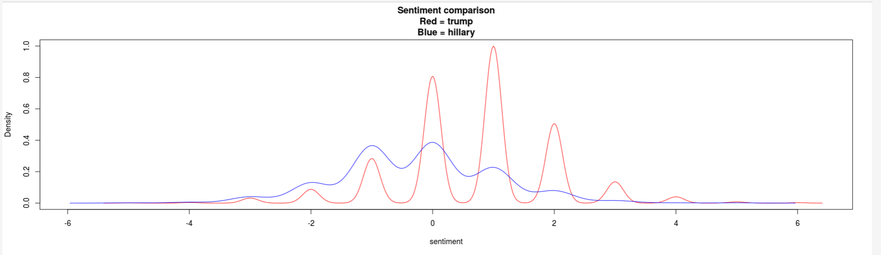

Kernel Density Estimation: The (S3) generic function density computes kernel density estimates. Its default method does so with the given kernel and bandwidth for univariate observations.

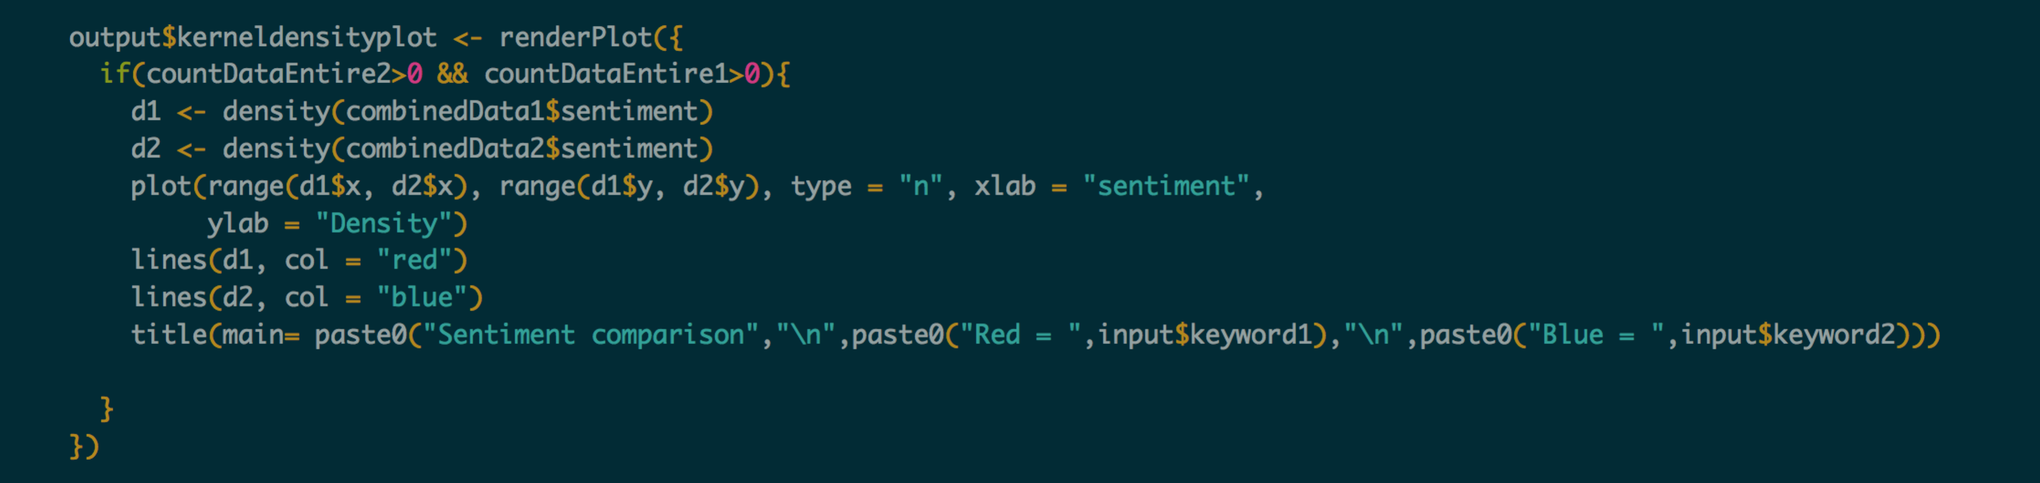

Twitter sentiments distribution: Distribute tweet sentiments: **anger**, **anticipation**, **disgust**, **fear**, **joy**, **sadness**, **surprise**, **trust**

**Observation**: For trump, there is more surprise tweet sentiments than trust. But, the least ones is disgust. For Hillary, there are more trust sentiments but there are anger sentiments after that. The lease ones is joy

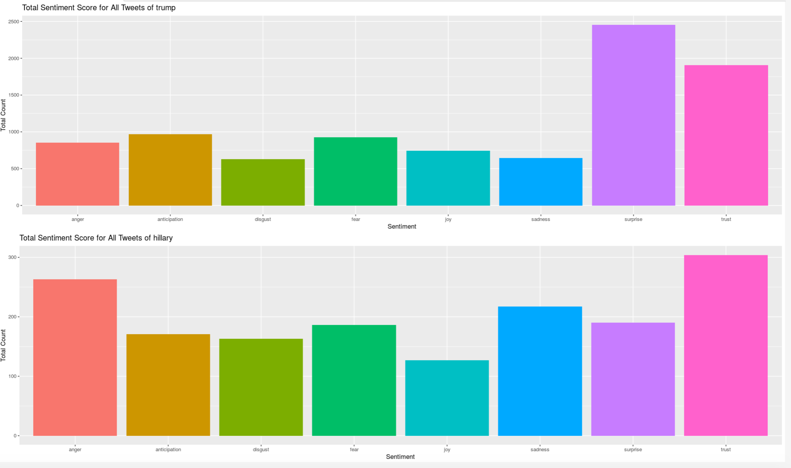

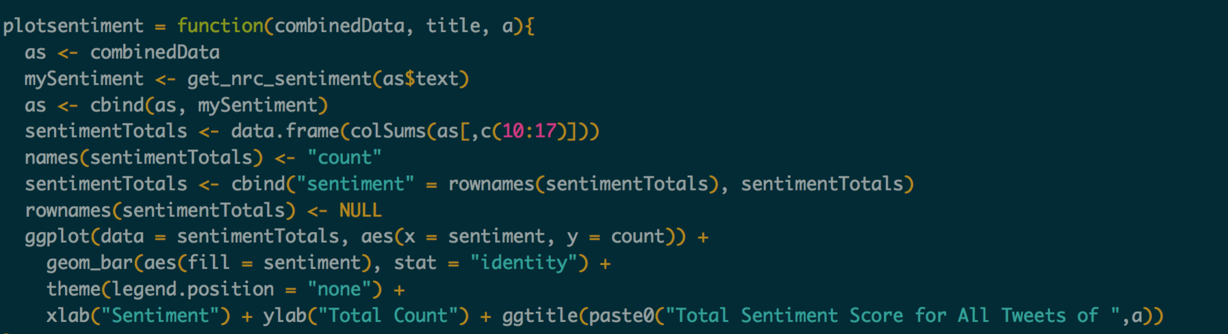

# Dashboard 2:

Purpose: It lets a user enter a text and output if the statement is positive, negative and neutral.

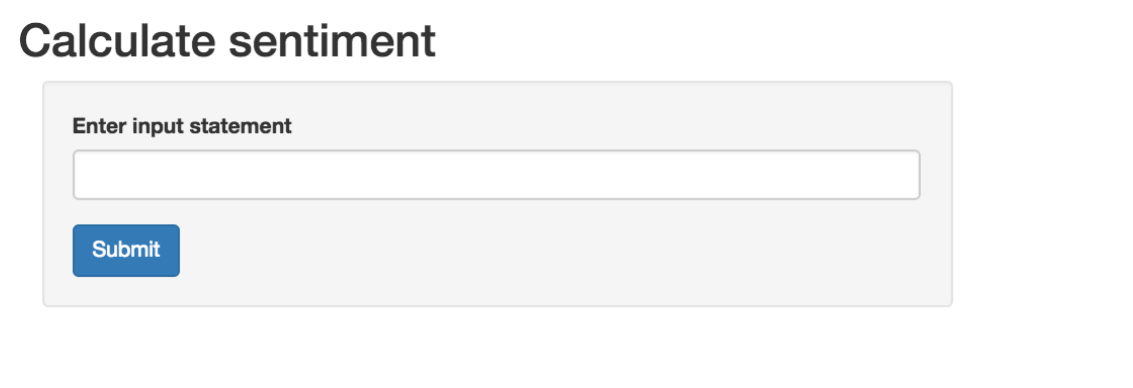

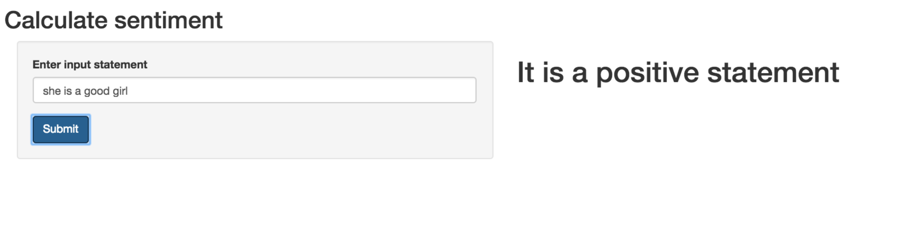

Model is created in azure and service is deployed. API call is made to service to retrive t he data.

**Prerequisite**:

Services can be called with any programming language and from any device that satisfies three criteria:

* Has a network connection
* Has SSL capabilities to perform HTTPS requests
* Can parse JSON (by hand or support libraries)

Once the experiment has been deployed, there are four pieces of information that we need to call either the RRS or BES service.

* 1. The service **API key** or **Primary key**
  2. The service **request URI**
  3. The expected API **request headers** and **body**
  4. The expected API **response headers** and **body**

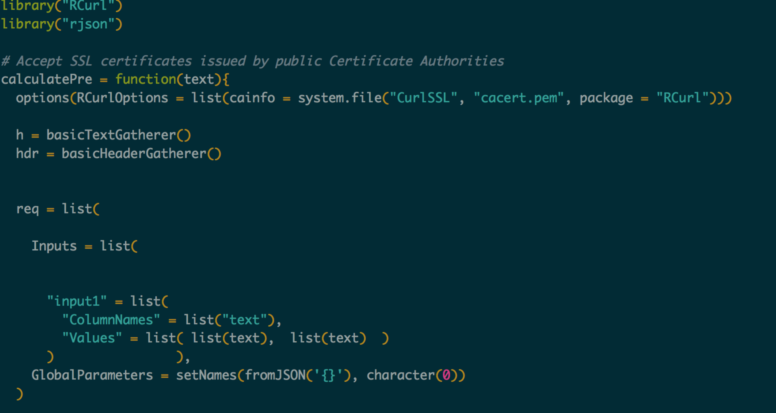

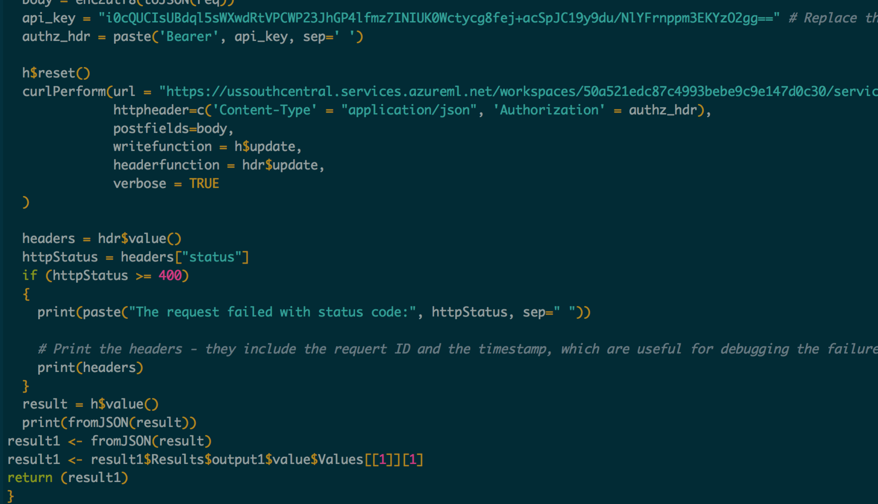

# Dashboard 3:

# Data Visualization

Tools Used: Tableau with Conduct Exploratory Data Analysis

Tableau Public was used to publish the visualizations on Website.

1. We collected two csv data about 10,000 lines data with key word “iPhone” and “iPad”.
2. Add sentiment and score label in each line of the original data source.
3. Finding the Top 10 Sources by Tweet Count. From the bar chart, most Tweet Count were from “dlvr.it”, and then is “WordPress.com” 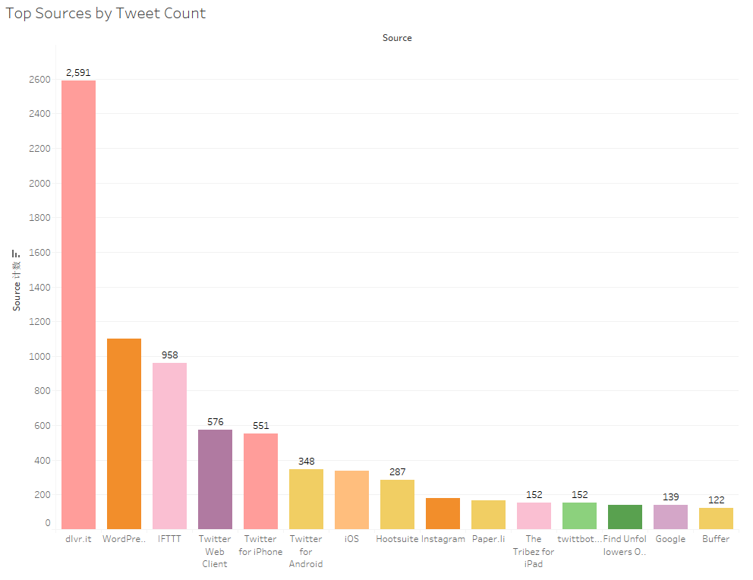
   1. Finding the Top 10 Sources by Retweet Count. From the bar chart, Twitter for Google TV had 7038 Retweet count, which is the highest, and then, is Twitter for Android.

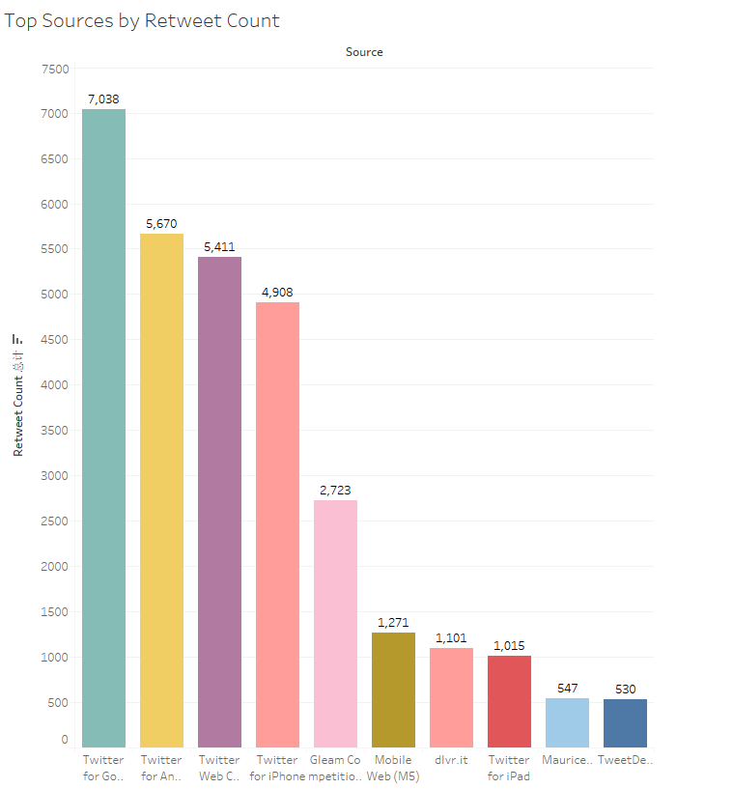

* 1. Top 10 Retweets from Data. The top one retweet is “FOLLOW US for a chance to win an iPhone” which had been retweet for 20,043 times. But this tweet is just an advertisement. 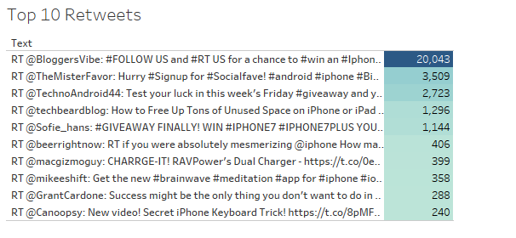
  2. The top 5 favorite count distribution shows most tweet did not have favorite. 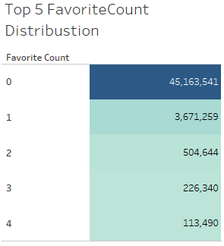
  3. The Text Length Distribution shows, most people write 131-140 words by using iPhone, and then is 141 – 150 words. 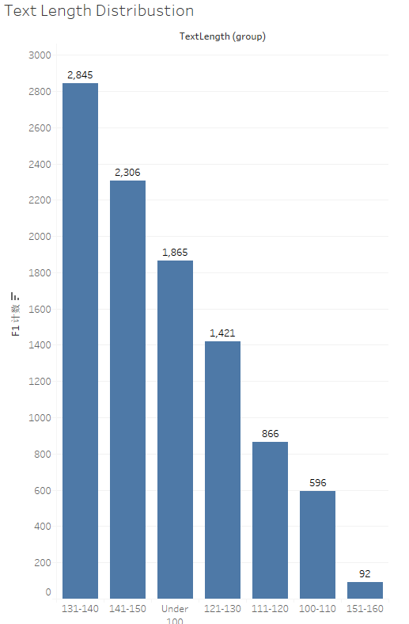
  4. Top 10 Retweet Count Distribution also shows most tweets were not be rewet, which is similar with Favorite Count Distribution. 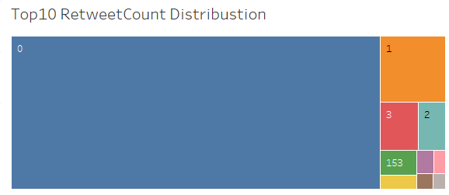
  5. Tweets by Hours shows that 9pm is the peak that people use iPhone to write tweets. The lowest time is 6pm. 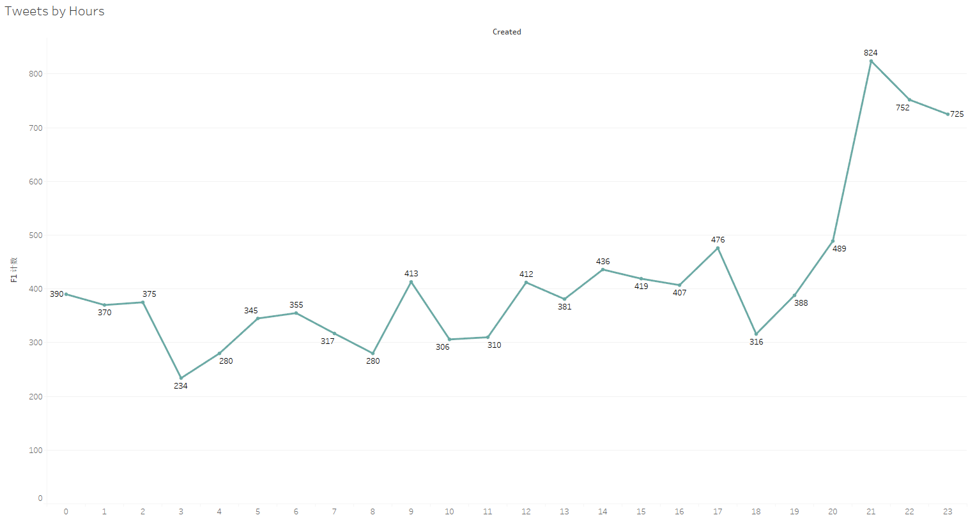
  6. Dashboard of iPhone and iPad:

iPhone: 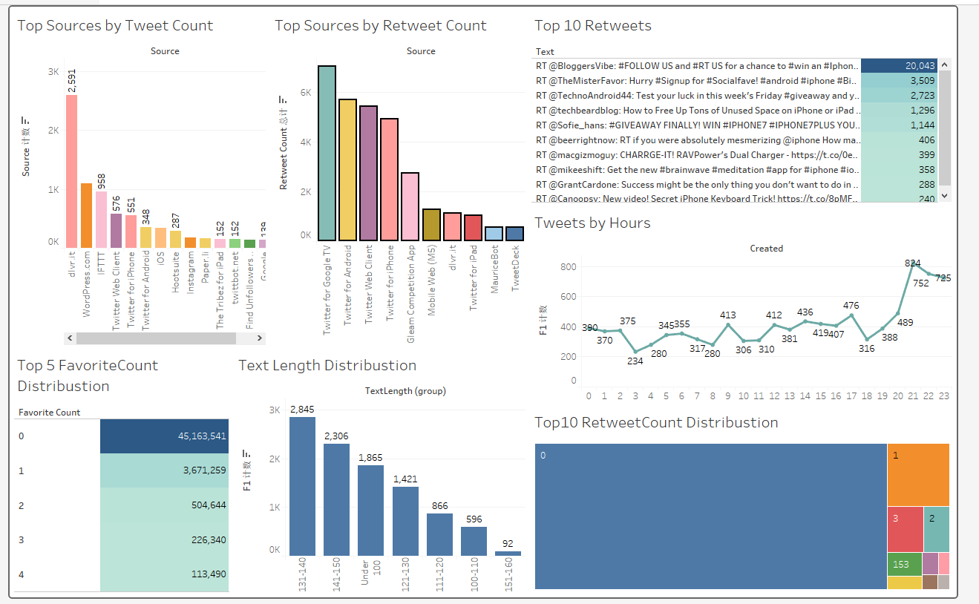

iPad: 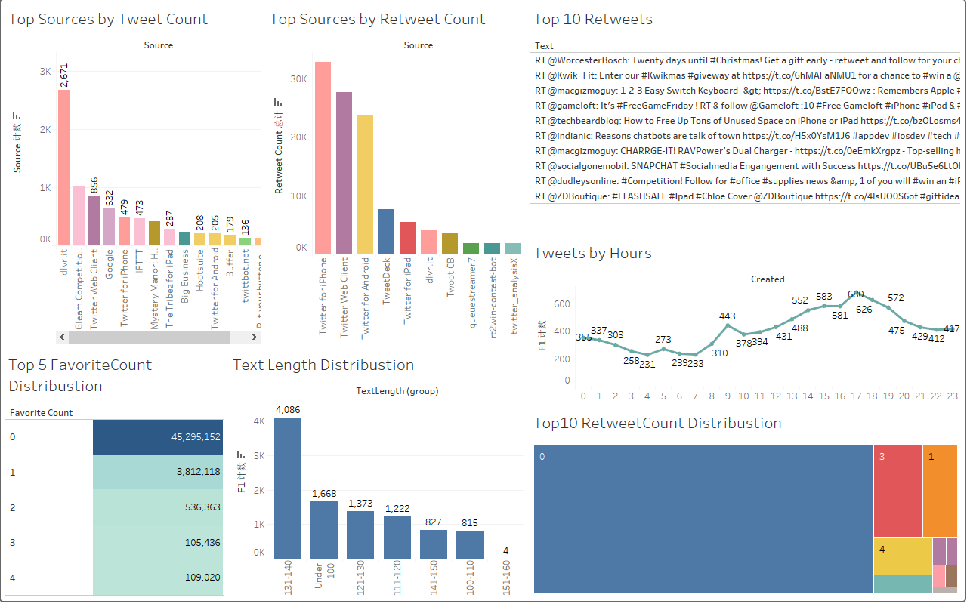

# Data Modeling

Tools Used: Microsoft Azure ML Studio

**Building the Model**

Steps:

1. Get Data by using R script. Dataset has 3 fields:

* Sentiment: the polarity of the tweet (0=negative, 2=neutral, 4=positive)
* Target: the query.
* Tweet_text: the text of the tweet. 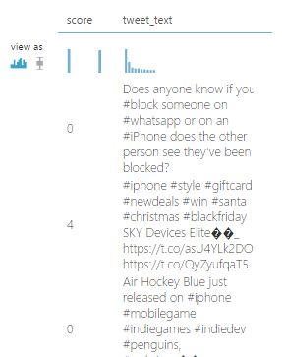

1. Text preprocessing using R script. Tweet usually requires some preprocessing before it can be analyzed. We used the following R code to remove punctuation marks, special character and digits, and then performed case normalization. 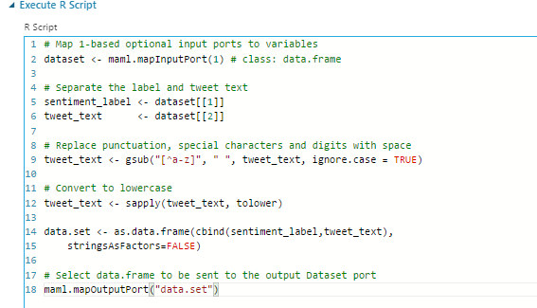
2. Edit Metadata. We used edit metadata to marked the text column as non-categorical column, and marked the text column as a non-feature. 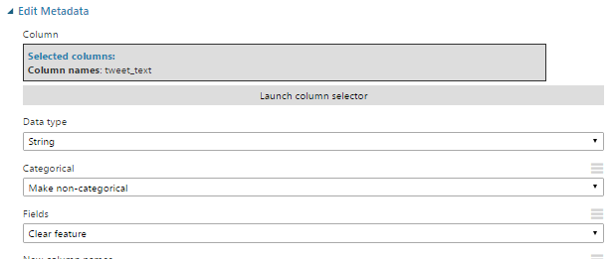
3. Feature Hashing, which can be used to represent variable-length text documents as equal-length numeric feature vectors. We set the number of hashing bits to 17 and the number of N-grams to 2. With these settings, the hash table can hold 2^17 entries in which each hashing feature will represent one or more unigram or bigram features.

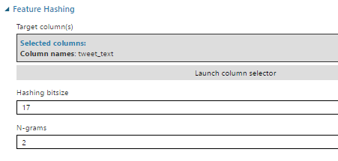

1. Split the data into train and test. We use 80% data for training and 20% for testing.

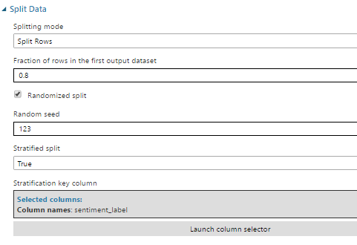

1. Train the model based on the algorithm: Two-Class Support Vector Machine Model

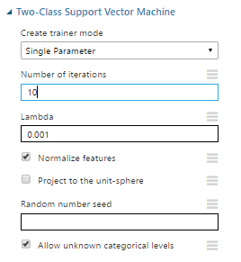

1. Evaluate the model

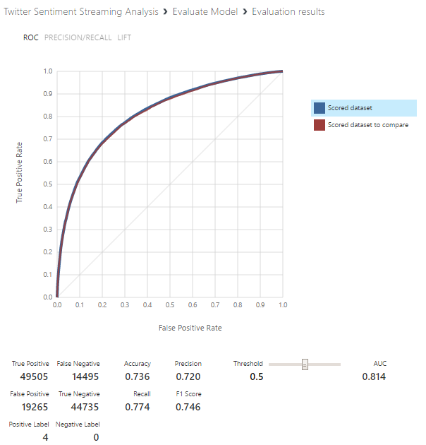

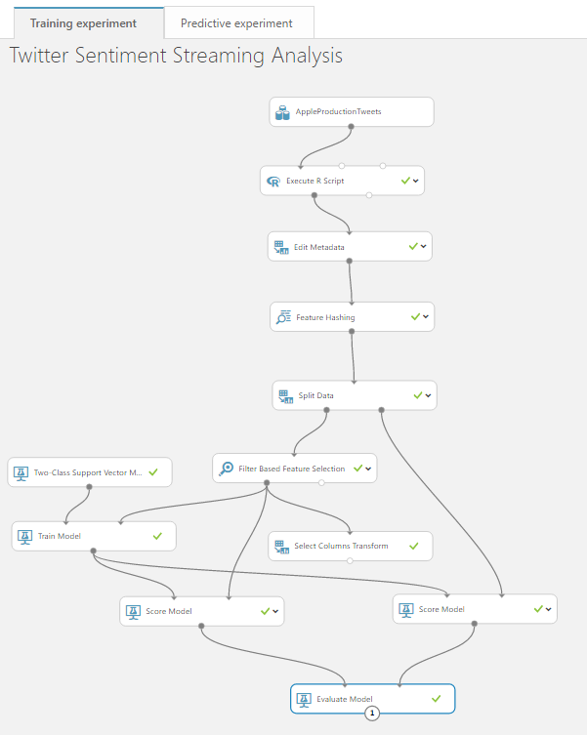

1. Add Web Service Input and Output.
2. Execute R Script Module:

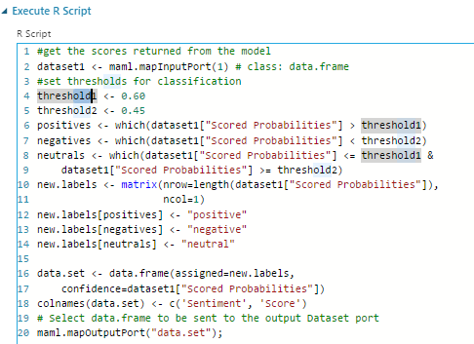

# Deploying the Web Service:

Steps:

1. The Web service is deployed using REST API in the by node.js in HEROKU server, and in the frontend the data is consumed using JQuery AJAX function. The Web Pages are redirected using Flask Framework which is a node.js framework used for request dispatching in the web applications
2. The technologies used for the FrontEnd are: Bootstrap, HTML5, CSS, Javascript, JQuery, Font-Awesome.

**Dashboard 4:**

# Integration of Front end and REST API

Technologies used: Node JS Server, Javascript

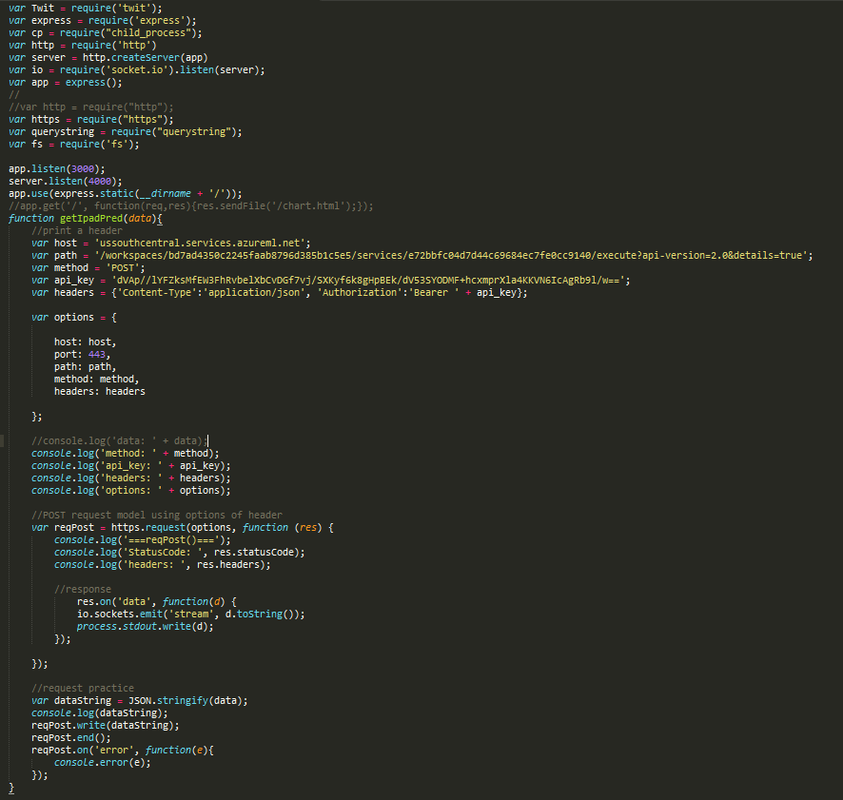

* Using REST API in the Node js Server
* In the Frontend calling the API using JQuery.
* The Front-End code snippet - Blank.html
* Index.html

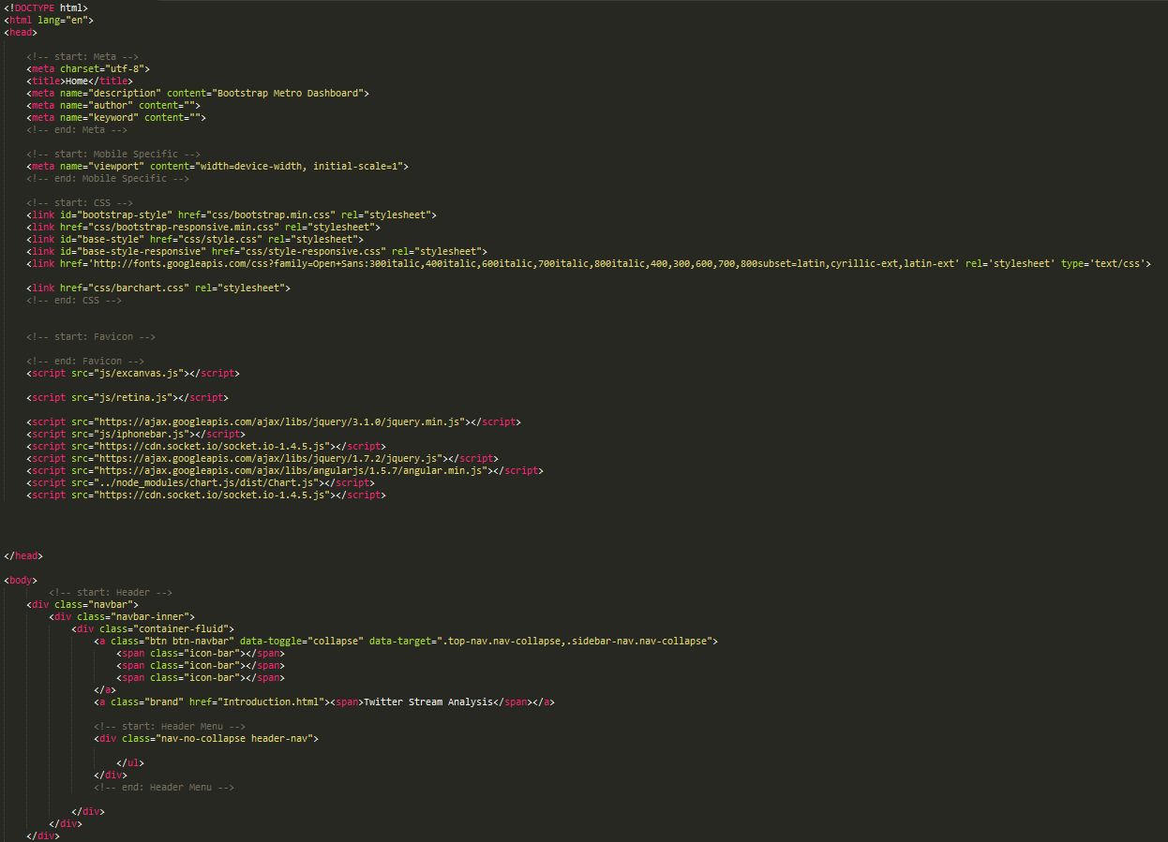

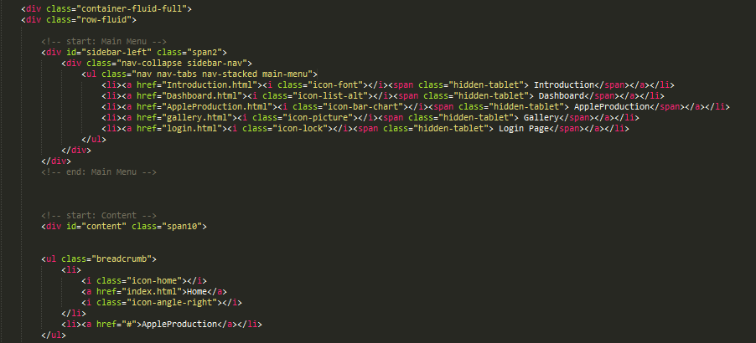

Dynamic Bar Chart:

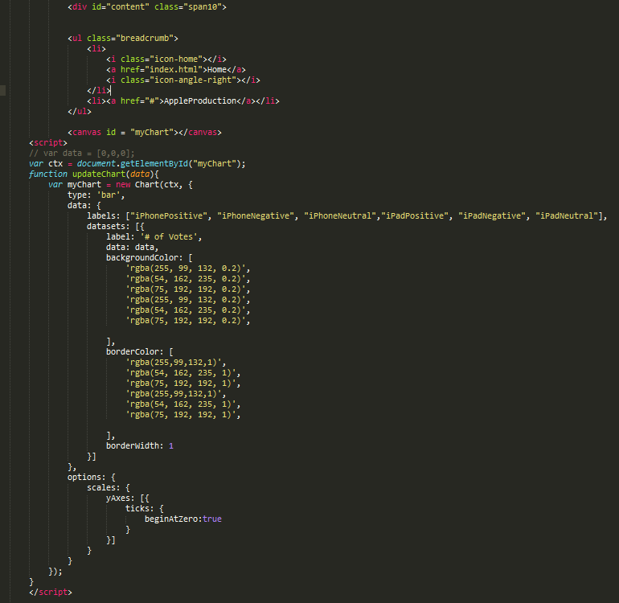

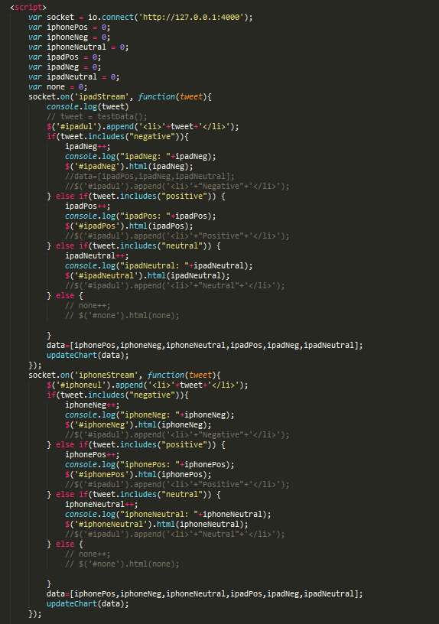

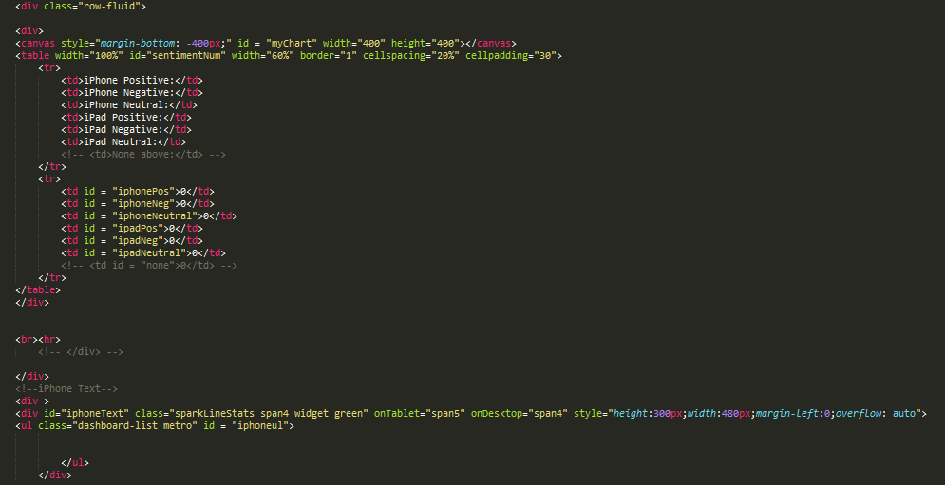

When you click the “iPhone & iPad” will connect to the AppleProduction:

You will see the dynamic Barchart will show the analysis output from AML Stream Analysis Model to show, how many iPhone and iPad user like or don’t like to use thest two product by analysis their tweets.

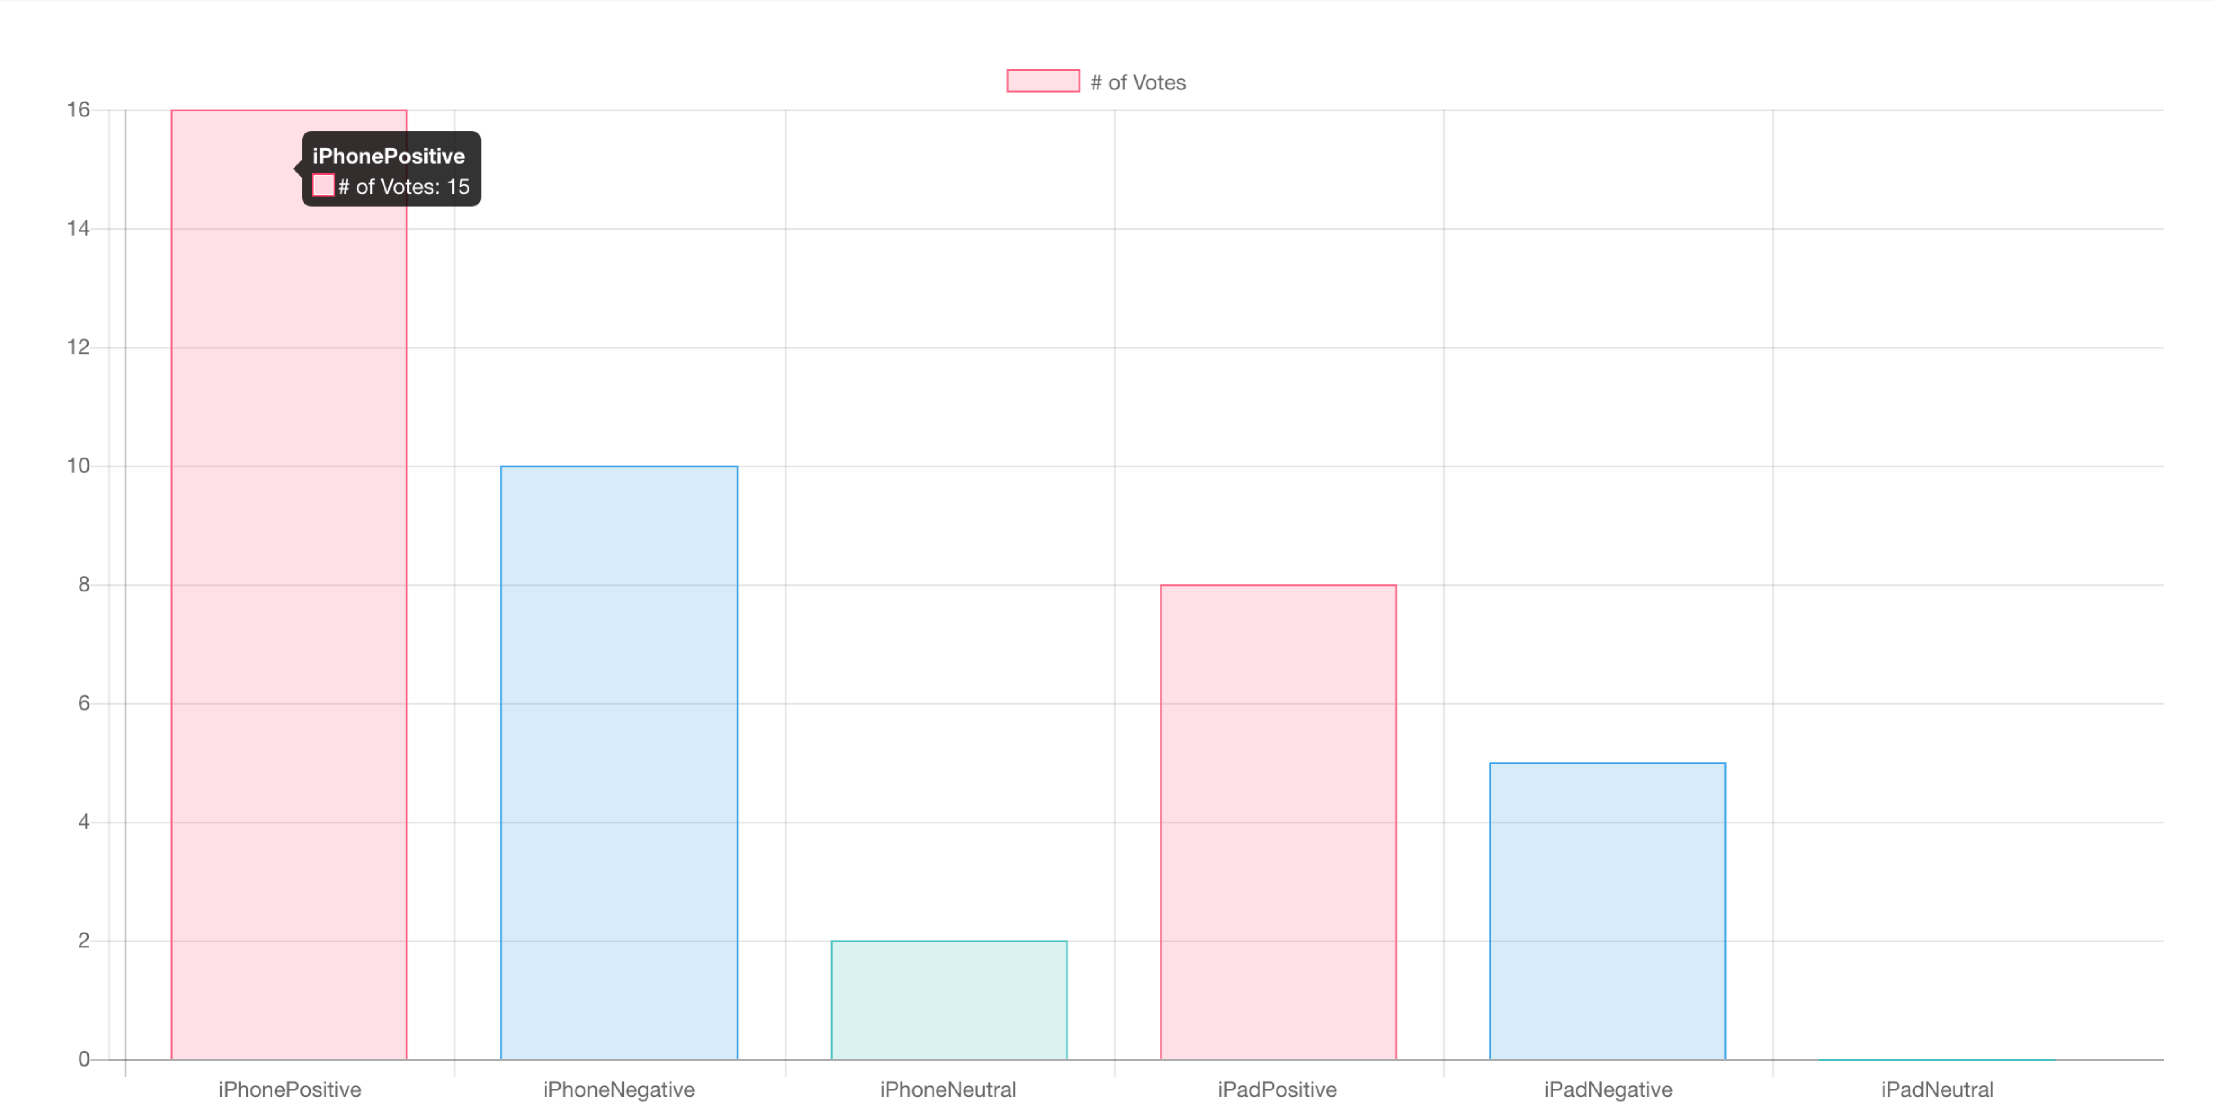

The table will colcuate how many people like or don’t like iphone and ipad.

The grean filed shows their streaming tweets.

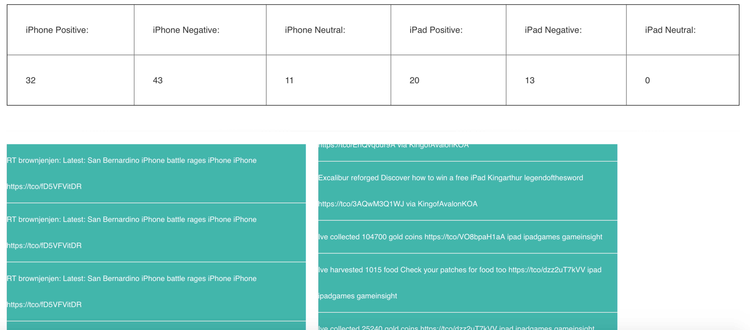

# Challenge

References:

<https://plot.ly/ggplot2/stat_smooth/>

<https://plot.ly/ggplot2/stat_smooth/#adding-trend-lines-in-r-with-statsmooth>

<https://susanejohnston.wordpress.com/2012/08/09/a-quick-and-easy-function-to-plot-lm-results-in-r/>

<http://stackoverflow.com/questions/7005483/geom-smooth-what-are-the-methods-available>

http://stackoverflow.com/questions/32908222/conditional-colouring-of-a-geom-smooth?rq=1